WA Sprint Distance Orienteering Championships 2014
Gosnells – Saturday 6th September 2014

Bring: SI tag, compass, whistle.
Facilities: Public toilets are close by, shade and shelter available under building verandahs.
Directions: The assembly area is near the City of Gosnells buildings. Enter the CoG car park off Albany Hwy just south of Gosnells Rd West or from Mills Rd West. Please park towards the Albany Hwy end of the car park as the Easy course passes through the eastern end of the car park. Do not enter the CoG parklands and obey all out of bound signs. Competitors will be able to warm up in the grassed area north of the car park (towards the Caltex service station).

Courses (straight line distances)

Course | Distance | Men | Women
1 | 2.8 km | M17-20, M21, M35, M45
2 | 2.1 km | M14, M16, M55, M65, M70 | W16, W17-20, W21, W35, W45, W55
3 | 1.5 km | M75, M80, M Open B | W14, W65, W70, W75, W80, W Open B
4 | 1.2 km (Easy Navigation) | M10, M12 | W10, W12

Map
Gosnells ISSOM 1: 4000, contour interval 2m (2014 – Paul Dowling)
The maps will be sealed in plastic bags.
Whilst the map is brand new and as current as possible, this area is open to the public and is urban parkland. Hence, some minor changes may occur at late notice and we will endeavour to make competitors aware of these where possible.

Impassable Features
As per all ISSOM maps, there are some features marked as impassable. It is NOT PERMITTED for any competitor to pass over these features under any circumstances. Weirs are considered impassable and this means impassable “over” as well as “along” – i.e. you may not pass along the top of the weir wall.

Importantly, a river runs through the map and is marked with a solid line at its edges, which means that competitors may not pass through the water/river. A number of bridges are clearly marked on the map and these MUST be used to cross the river. Jumping the river is not permitted (although, if you can manage this, give the AIS a call as a place on the Australian Olympic Long Jump team beckons!)

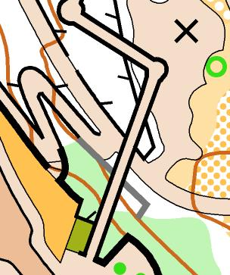
In the southern part of the map there is a long, elevated (up to 5m high) walkway. This structure has been mapped as a bridge (ISSOM 512.1) and has been mapped over the top of contours and other features at ground level to emphasise its separation.

For almost its entire length, the walkway is easily passable underneath – it is possible to use the walkway itself as a route choice, but obviously competitors should not attempt to leave the walkway mid-length!

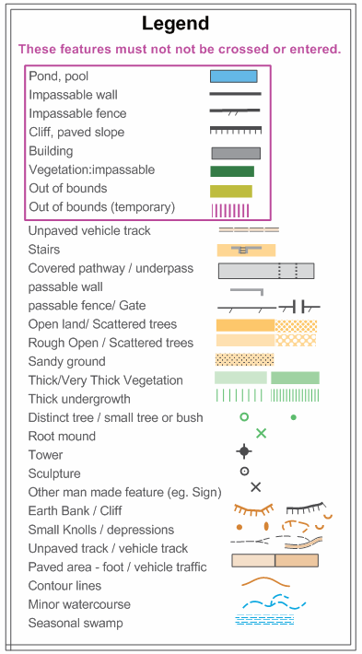
In the wetlands area there are also some ground-level walkways with railings – these have been mapped with the ‘Passable Fence’ (ISSOM 522.0) symbol and are passable as usual.

The legend may be obscured by control descriptions on some maps, so please familiarise yourself with ISSOM symbols before the event. The legend will be clearly visible on Course 4 maps. Copies of the legend will be on display at the assembly area and at the start.

Starts (for all courses)
This start is about 100m from the assembly area, through open parkland below the southern end of the raised decking. Once started on their course, runners must follow cones from the pre-start for about 55m to the start triangle which will be marked by a control stand and flag but no punch. Competitors will be able to warm up in the grassed area north of the car park (towards the Caltex service station).

Start Procedure
Competitors will be called up three minutes before their start time. Please clear and check SI sticks before entering the start area.
Box 1 – name and SI stick number checked
Box 2 – SI checked and control descriptions collected
Box 3 – competitors move to correct map box and write name on back of map
Start time – punch the Start SI unit before looking at your map, then start your course by following the cones/streamers to the start triangle (about 55m).

Late Starters
Late starters should report to the Start officials. They will be started as soon as possible but timed from their original start time unless delayed by a fault of the organisers or by events considered by the Controller to have been unavoidable by the competitor.

Water
No drinking water on any courses.

Sportident Tags
If you have hired an SI tag, collect it from the registration table before going to the start. Clear and check stations for SI tags will be at the start. If a SportIdent control station fails, you must punch your map using the punch on the control stand and mention this when downloading your results.

Control Descriptions
Control descriptions will be printed on the front of maps. IOF symbols will be used for Courses 1, 2 & 3 and English for Course 4. Loose control description slips will be provided at the pre-start.

Course Notes
On Courses 1, 2 & 3 there is a pivot control that is visited more than once. Runners must punch this control each time it is visited.

Competitors on Course 4 (M/W 10 & 12) will pass through two car parks and will need to be aware of possible traffic movement in these areas.

Complaints and Protests
Complaints should first be made orally at the event to the Controller who will direct the complainant to the appropriate official. Protests about the outcome of a complaint must be made in writing and given to the Controller. If this occurs, a jury consisting of three Level 2/3 Controllers will be convened to consider the protest. Protests should be submitted by 3pm.

Course Closure
Courses close at 4pm. Controls will be collected from this time.

Enter-on-the-Day
Two Enter-on-the-Day courses will be available after all official competitors have started. These will be a separate course similar in standard to Courses 1 – 3 of length 2.3 km and also Course 4.

Presentations
Awards will be presented at approximately 3 - 3.30pm or as early as is practicable.

