Vic Autumn-Spring Series, Glenlyon Forest
Sunday 1 August 2021

IMPORTANT
Please keep abreast of Covid-19 updates, and remember - you must not take part in this event if you are unwell with Covid-19 symptoms, if you are waiting for test results, or if you are otherwise required to quarantine or isolate.
Your entry fee will be refunded if you are unable to attend due to the date change,
or in order to comply with health directives.
Arena Green Gully Rd, Glenlyon
(Google Maps reference -37.2642693629145, 144.22773769026918)
Start Times
Courses 1-5: 10am – 12noon Course closure: 2pm sharp
Score course: 10am – 10.30am Course closure: 12.30pm sharp
Terrain | Glenlyon Forest is on the Country of the Dja Dja Wurrung People. We acknowledge that their forebears are the Traditional Owners of the land we are meeting on and have been for many thousands of years. The Dja Dja Wurrung People have performed age old ceremonies of celebration, initiation and renewal. We acknowledge their living culture and their unique role in the life of this region.  This is traditional gully spur terrain, steep in some sections, with patches of thick undergrowth and some attractive rock features.

Organiser Wendy Taverna centralhighlandsorienteers@gmail.com 0439433665
Map A4 printed on Pretex (waterproof paper)
Scale 1:10,000
Course planner Ian Phillips Course checker Mark Hennesey
COURSES See the list below. If you are unsure which to choose, contact the organiser.
On the day, coaching and assistance will be available to newcomers.
Course | Classes | Length / Navigational Difficulty | Distance (km) | Number of Controls | Approx. Climb  metres
1 | M1, W1 | Long / Hard | 7.3 | 25 | 235
2 | M2, W2 | Medium / Hard | 5.1 | 21 | 175
3 | M3, W3 | Short / Hard Navigation  but physically moderate | 3.2 | 13 | 115
4 | M4, W4 | Medium / Moderate | 2.9 | 11 | 105
5 | M5, W5 | Short / Easy | 2.1 | 12 | 40
SCORE | - | As easy or hard as you make it – get as many controls as you can in 2 hours. NOTE: at this event, each control has a particular score value
Timing SportIdent electronic timing will be used for all courses.
SI sticks are available for loan if you do not have one.
If you have an SI Air (SIAC) stick, please enter with and use that.
Entry Fees Full financial OV members adult $22, junior $12
Non-members / Casuals adult $32, junior $22
Family max: $56

Pre-entry Online entries close on Wednesday 28 July at 11.59pm.
Please make sure your phone number is included.
Pre-entry via Eventor is strongly preferred. There will be a prize draw for pre-entered competitors. Limited entries on the day are accepted subject to any government restrictions/entry caps and map availability. Please pre-enter to avoid disappointment and make it easier for the organisers.

Enter on the Day Subject to map availability - cash payments - correct money if possible.
On arrival Scan the QR code and show the Check In Confirmation screen at Registration.
No Scan, No Start

Toilets Available at the assembly area.
Please use supplied hand sanitiser before and after using toilets.
Catering BYO water and food.
Water Please bring AND CARRY your own water if at all possible. Courses 1-4 will have a VERY LIMITED number of bottles of water out on the course. If you do take one, please dispose of it after use in the bag provided. Do not share it with anyone.
No water will be provided at the start or at the finish – please bring your own.
Start The start is 40 metres from the assembly area.
Results Live results available – link via QR code on map https://liveresultat.orientering.se/?lang=en
PRIZES! Gather at 12.45pm (in a socially distanced way) for the presentation of these.
There will be small prizes for course / class winners (including the score course), the sprint competition in each class on courses 1-5 (last control to Finish line), the fastest sprint of the day, plus a pre-entry prize draw.

DIRECTIONS
From Melbourne
From Melbourne take the Calder Fwy to the Malmsbury exit. Turn left when leaving Malmsbury onto the Daylesford-Malmsbury Rd, heading south-west. Follow all the way to Glenlyon. Turn right onto Ford St at the Glenlyon General Store (open from 8.30 am to 3 pm). After approx. 1.2km turn right onto Green Gully Rd. Stay on Green Gully Rd as it turns left at the T-intersection and proceed for approx. 3.5 km to the assembly area.
From Bendigo
From Bendigo take the Calder Fwy south to Malmsbury and follow directions from Melbourne as above.
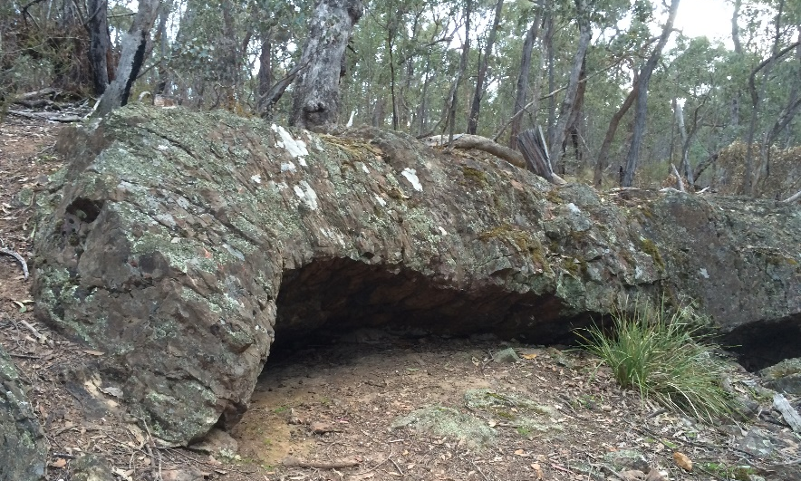
From Ballarat
From Ballarat travel to Daylesford, take the Daylesford-Malmsbury Rd heading north-east toward and Glenlyon and turn left into Ford St at the Glenlyon General Store. Follow directions from Melbourne as above.

