MTBO National Series Round 3
WA MTBO Championships
Margaret River
Bulletin 3

The Orienteering Association of WA invites riders to attend the final round of the 2014 MTBO National Series, to be held in and around the picturesque tourist destination of Margaret River, WA. This region boasts some great tourist spots including wineries, restaurants, adventure activities and food, in addition to also being a quality mountain biking destination and hosting part of the Cape to Cape mountain bike race.
Margaret River is located approximately 3.5 hours’ drive south of Perth and is right near the coast for those also into beach activities, boasting world class surfing.
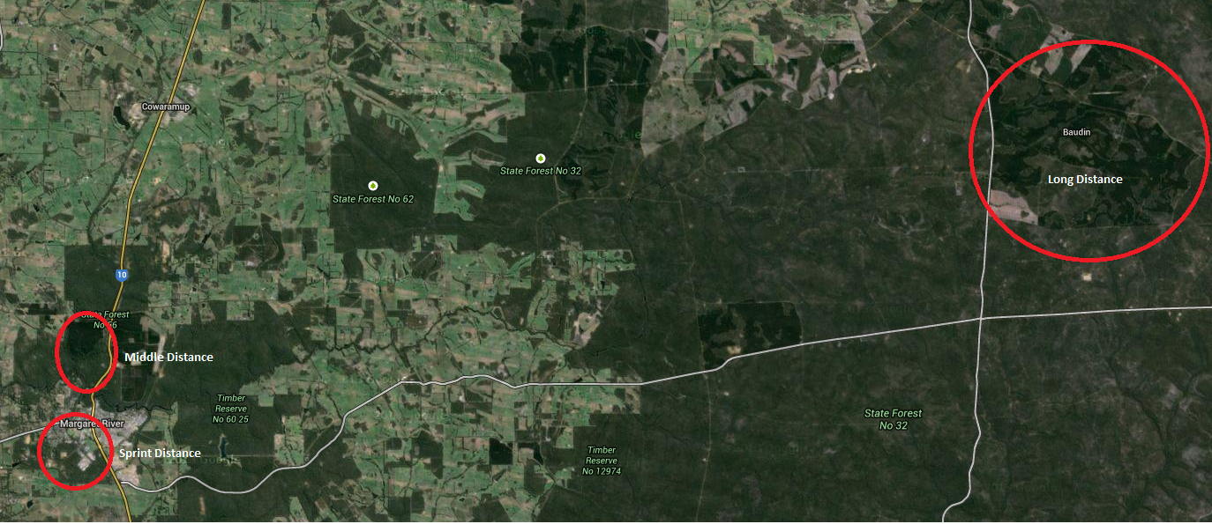

The event weekend will feature three races:
- Friday October 10th (from 1pm) – WA Long Distance Championships
- Saturday October 11th (from 9am) – WA Middle Distance Championships
- Saturday October 11th (from 2pm) – sprint distance event

This event also concludes the National Orienteering Carnival (Karrak Karnival) that works its way from Perth to Margaret River over the period September 27 to October 5 and Sprint the SW on October 7-8 (Bunbury and Margaret River region).

Expected Winning Times (in minutes): (as per revised OA operations manual 2014)

 | Long Distance | Middle Distance | Sprint Distance
Junior Men | 84-92 | 44-48 | 16-20
Junior Women | 68-76 | 36-40 | 16-20
Senior/Masters Men | 105-115 | 55-60 | 20-25
Senior/Masters Women | 85-95 | 45-50 | 20-25

Note that due to the updated IOF expected winning times, the course/class combinations listed in previous Bulletins no longer apply. Please see individual events for the new lists, as these may be different for each event.

Start procedure
Riders will start at two minute intervals across all races within each category. The start procedure, which is the same for all events, is as follows:

4 minutes before your start: called up to the start grid and have your SI number checked off
2 minutes before your start: move forward to the map table and given course instructions
1 minute before your start: take your map
Start time: start riding! (it is intended that there will be no start brick although this may change on the day)

If you miss your start time, you will be slotted in at a later start at the discretion of the starter. Your time will still be recorded from your original start time, unless due to extraordinary circumstances or pre-arranged.

WA Long Distance Championships
Location: Baudin Plantation, 55km by road east of Margaret River
Directions: From Perth - Travel south on Mitchell Freeway, Forrest Highway and Bussell Highway towards Busselton. 40km from the southern Bunbury Bypass roundabout, turn left in to Sues Rd (just before reaching Busselton), and travel south for 18km, then turn left in to Jalbarragup Rd. Travel east 8km and turn right in to Lily Rd for 2km to assembly area.
From Margaret River – From Tourist Centre, drive south 2.9km, then turn left on to Rosa Brook Rd and travel east 33.4km. Turn left into Sues Rd and travel north 9.6km, then turn right on to Jalbarragup Rd. Travel east 8km and turn right in to Lily Rd for 2km to assembly area.
Start times: from 1pm; EOD starts after registered riders, last start 2pm.
Warm up: Along Lily Rd north of the assembly area.
Terrain: Mostly flat terrain at the headwaters of Margaret River, with some slightly steep gullies in parts. Mature pine plantation with blocks of remnant native vegetation. Tracks generally firm, but riding speed slowed by fallen leaves and sticks, thick cover of pine needles in the plantation, and undergrowth on tracks in native bush. Some parts are sandy, other wetter areas have deep ruts from forestry machinery. Trail bikes have used some trails and often these are easier to ride. Otherwise the tracks get very little if any traffic, so expect tracks and junctions to be less distinct on the ground because of a cover of leaf litter.
Map: Margaret’s Other End. 1:20 000, 5m contours. Approx. 30x30cm
Notes: Most of the native vegetation is dense, so for clarity all native forest has been mapped as dense (green). Most of the pine plantation is mature, and mapped as open forest (white). Some dense young pine is mapped as green with a lighter symbol than used for native forest. In the mature pine, some rows of trees have been felled to thin out the forest, and these can be mistaken for tracks. Tree stumps and/or a central mound will indicate a felled row rather than a track, these rows are not rideable unless mapped as an optional marked route (purple dashed line) and marked in the terrain with tape. These marked routes have been created along felled rows in a few locations to assist in course setting options and these may be ridden, but are optional. These will mostly be equivalent to slow riding and have been checked for relatively safe riding by the organiser.

We have been advised there will be some track clearing work in the week preceding the event so some obstructions mapped may be cleared since maps were printed.

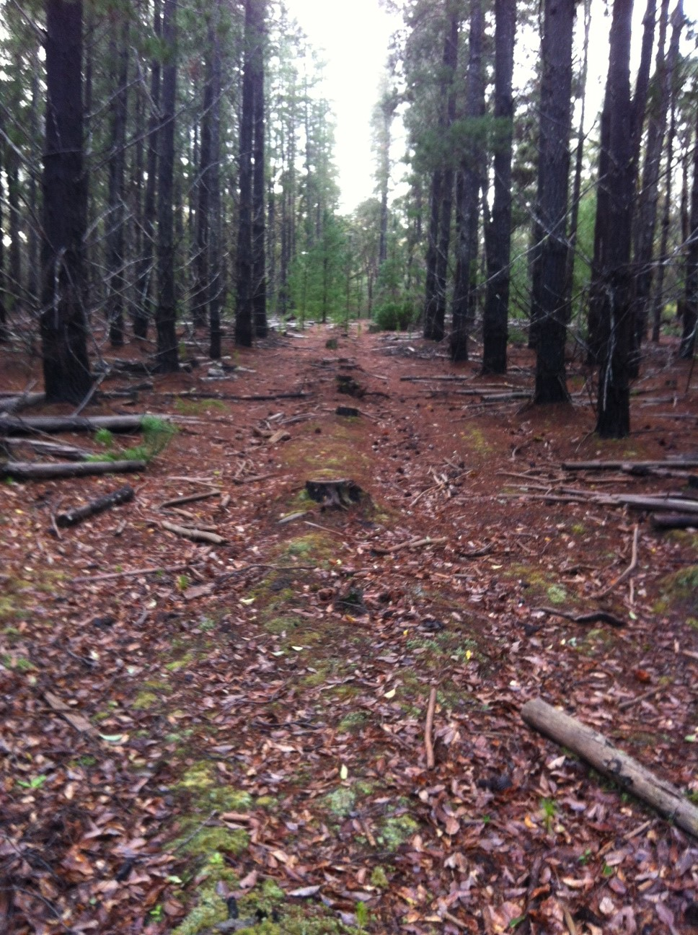
Example of a felled row. This should not be ridden unless taped with pink tape and mapped as a marked route.

Facilites Portable toilet. Mobile phone coverage is weak and patchy with Telstra. Nearest shops are Busselton and Margaret River – no water provided on courses.
Course close: 5pm
Setter: Duncan Sullivan
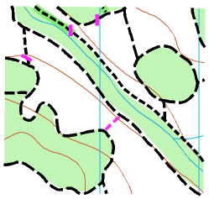

 | Classes | Distance | Climb | Controls
Course 1 | M21 | 33.0km | 170m | 21
Course 2 | M40, M50 | 28.6km | 150m | 18
Course 3 | W21  M20, M60 | 23.4km | 140m | 14
Course 4 | W20, W40, W50  M16, M70 | 19.7km | 130m | 12
Course 5 | W14, W16, W60, W70, W80  M14, M80 | 14.1km | 75m | 10

*Model event for WA long distance champs*

An unmanned model area will be set up for use on Friday morning so that competitors can familiarise themselves with the trails and mapping used for the Event. This will be on the South side of Jalbarragup Rd, 4.4km from the turnoff from Sues Rd. (400m past intersection with Marlock Rd). Maps will be available in a plastic box. Three control markers will be put out. A ride around the trails will be about 2km, although some may prefer a shorter ride or even a walk around. There will be no toilet on site; go to the main event assembly area (about 6km further) for one, as this is a sensitive water catchment area.

WA Middle Distance Championships
Location: Wharncliffe Mill, Margaret River
Directions: From Perth - Travel South on Mitchell Freeway, Forrest Highway and Bussell Highway to Margaret River. Just before crossing the river on the northern edge of town, turn right into Carters’ Rd. Travel 1.1km, turn right into McQueen Rd and follow signs.
From Margaret River - Head north from town. After crossing the river, turn left into Carters’ Rd and follow the directions above.
Note: It is preferred for those staying in town to commute to the assembly area by bike due to limitations on parking arrangements at the mill.
Start times: from 9am; EOD starts after registered riders, last start 10am.
Please note the start is approximately 1.7km from the assembly area. Directions to be provided from there.
Warm up: On the railway trail between Carters Rd and the turn off to the pre-start.
Terrain: Pine & native forest with dedicated MTB trails
Map: Carters’ Pines. 1:10 000, 5m contours. A3
Notes: The area is a mix of pine and native forest, with much of the pine forest thinned by logging. These areas are open but presently marked as ‘rough open, scattered trees’ (unrideable land – see the symbol set below). There has been no logging in the area as previously warned so it is all open to us.

Many of the single tracks are single directional and will be marked as such on the map (see one way symbol in the symbol set below). This is done mainly to prevent incidents with other trail users on the day and because these tracks are meant to be ridden in the direction indicated. Please do not ride them the wrong way. Feel free to make use of the MTB trails after the event (not before)!
Facilities: Toilets, showers for campers, camp kitchen. Margaret River township is a short ride away.
Course close: 12:30pm
Setter: Ian Dalton
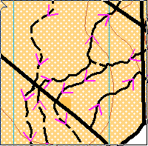

 | Classes | Distance | Climb | Controls
Course 1 | M21 | 17.5km | 320m | 17
Course 2 | W21  M17-20, M40 | 15.8km | 305m | 15
Course 3 | W17-20, W40  M16, M50 | 13.0km | 180m | 13
Course 4 | W16, W50  M60 | 11.5km | 225m | 14
Course 5 | W14, W60, W70, W80  M14, M70, M80 | 10.6km | 165m | 13

Sprint Distance Event
Location: Margaret River Leisure Centre, Margaret River
Directions: From the corner of Bussell Hwy and Wallcliffe Rd, travel west along Wallcliffe Rd for 500m to the leisure centre parking on your left (signed). Please park in this parking area. To get to the assembly area (approx 400m), from the western end of the car park, take the bitumen road south (riding, not driving!) to a T junction with a gravel road. Turn left (east) and follow this to another bitumen road, where you turn right (south) to the assembly area. Note that you will be passing through the course at this stage so take care if you are arriving late.
Alternatively if riding to the event (particularly if staying at the Tourist Park on Station Rd), from Station Rd, ride west along Shepherdson Pl (south side of Home Hardware; this won’t be marked with orienteering signs). At the end of the road, follow the cones around the north side of the tennis courts to the assembly area. Once again note that you are on the course at this stage so please do not deviate from this route.
Start times: from 2pm; EOD starts after registered riders, last start 3pm.
Please note the start is approx 1.7km from the assembly area. Directions to the start will be provided at the assembly area.
Warm up: On the way to the start. Please note this is a trafficked area.
Terrain: Native bush tracks and urban parklands, minimal climb on all courses
Map: Gloucester Park. 1:7500, 5m contours. Approx. 30cm x 25cm
Notes: The course contains a mixture of variable speed riding tracks, residential roads, parklands, high school and sporting grounds. Please be courteous to other area users. There are some out of bounds areas along major roads and construction areas within the school grounds as well as the skate park (for safety reasons). Roads are not closed so riders must abide by normal road rules! Paths (where these exist) alongside OOB roads are allowable.

The map was originally produced in the ‘dry’ but has since had substantial rainfall, meaning some tracks are now underwater. These track grades have been revised to account for the water level but there is no special distinction between these and other tracks on the map. The course mostly avoids waterlogged tracks but in some instances this was not possible. Short sections of water have not been graded.

After the bush section, all courses enter the urban part of the map. Upon entering Gloucester Park, courses 1-3 then exit the area and cross a road. Please be aware of traffic on this road as it is a commercial area and has moderate traffic. All riders turn right on this road and then immediately left into the car park for the “Outloud Dance Academy” before entering the high school grounds through a gate in the rear of the car park (marked on the map with the ‘crossing point’ symbol).

On all courses, from the final control to the finish, you must ride the marked route around the oval, not across it.
Facilities: Toilet, water, shops nearby, skate park & BMX track.
Course close: 4:30pm
Setter: Ricky Thackray
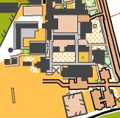

 | Classes | Distance | Climb | Controls
Course 1 | W21  M17-20, M21, M40 | 8.3km | 25m | 22
Course 2 | W17-20, W40  M16, M50 | 7.8km | 25m | 20
Course 3 | W16, W50  M60 | 7.0km | 20m | 18
Course 4 | W14, W60, W70, W80  M14, M70, M80 | 6.2km | 20m | 17

General course notes
WA uses an overgrown track symbol, a mid green overlay on a track symbol indicating appropriate riding speed. These tracks typically have 1.5-3m high shrubs growing from the original track surface that may hinder riding speed of ease or seeing where the track goes. A gap in the trees and the ground surface will distinguish the actual track from surrounding bush.

Fallen logs mapped as obstructions may be climbed over, but it is often easier and allowable to ride or walk around them in the forest. In places motor bikes or 4WD vehicles have created a path around these obstructions. Small fallen logs that can be cleared by skilled riders have not been mapped as obstructions.

Notes on symbols to be used across events
The following symbols will be used to denote areas across all maps:

Track symbols
Rideable land
Unrideable land
Other symbols
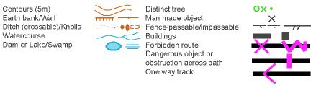
National MTBO League:
The Sprint, Middle and Long Distance MTBO Championships comprise the third and final round of the 2014 National MTBO League Elite, Junior and Masters Division Series. For information on classes eligible for the Australian National MTBO League, Juniors and Masters Division, see the website http://www.orienteering.asn.au/mountainbike/MTBONOL/

EVENT ENTRY
Online entry is now closed. Two enter on the day (EOD) courses will be available at all events. These will be Course 2 and Course 4. EOD fees are $25 members/$35 non-members ($15/$20 juniors) but entrants will not be entered into Championship categories.

SportIdent Hire: All competitors will require their own SportIdent stick. They are available for hire at the event. Alternatively if you wish to buy your own contact the organiser to enquire on purchase.

Map boards: A basic map board which can be attached to your handlebars can be hired at the event.

TRAVEL AND ACCOMMODATION
The best way to get to the event is to fly to Perth (if you do not already live there) and drive to Margaret River. The long distance event will require motorised transport to get to and from the town. The sprint and middle distance will be located a short ride from the town centre.

There are many accommodation options in and near town including holiday villas, caravan parks and B&Bs. The event is to be held during the WA school holidays and many places are now booked out. The event organisers’ preferred accommodation option is the Wharncliffe Mill Bush Retreat http://www.wharncliffemill.com.au/ , which is also the Event Centre and assembly area for the middle distance event (cabins and dorms now booked out; camping options available). It is also located within the heart of the best mountain biking trails in SW WA. Please mention that you are staying as part of the mountain bike orienteering carnival so that we can receive preferential treatment.

The Margaret River Tourist Park http://www.margaretrivertouristpark.com.au/ is also located close to the town centre and to the assembly area for the sprint distance event. For other accommodation options in and near Margaret River, check out http://www.margaretriver.com/accommodation/

RESULTS AND PRIZE GIVING

The dinner venue is Goodfellas, 97 Bussell Hwy, Margaret River. Dinner will be from 6:30pm Saturday, October 11, with prize giving throughout the evening. For a sample menu, go to http://img.dimmi.com.au/menu/19499-goodfellas-margaret-river-menu-dinner.pdf

There is an option in Eventor to elect to attend the dinner to get an idea of numbers. Please choose this option if you wish to attend. There is no need for upfront payment if choosing this option.

JURY

In the event of complaints or protests, a three person jury will convene to decide the matter. The jury can be selected from any of the following who may be available at the event:
Craig Steffen (Qld)
Kathy Liley (Vic)
Richard Matthews (WA)
Malcolm Roberts (NSW)
Blake Gordon (Vic)
CONTACTS/MAPPERS

Event organiser/primary contact

Ricky Thackray (WA MTBO Convenor, sprint)
rickythackray@hotmail.com
0459 486 739

Co-organisers

Ian Dalton (middle)
ian_dalton@hotmail.com

Duncan Sullivan (long)
duncange@bigpond.net.au
08 9285 0290

Course vetter

Phil Dufty
phil.dufty@westnet.com.au

