Come and Try Foot Orienteering in the Park
Where: Cooroy Sports Complex – Vehicle entrance off Mary River Road, Cooroy
Location on Google Maps
When: Sunday 6th March
Time: Start times between 9:00 am and 10:30 am. Courses close at 11:30 am
What to bring: Hat, sunscreen, water, comfortable shoes and clothes, a compass if you have one and a mobile phone if you want to run the 5 km course. Also cash or card if you have not prepaid.
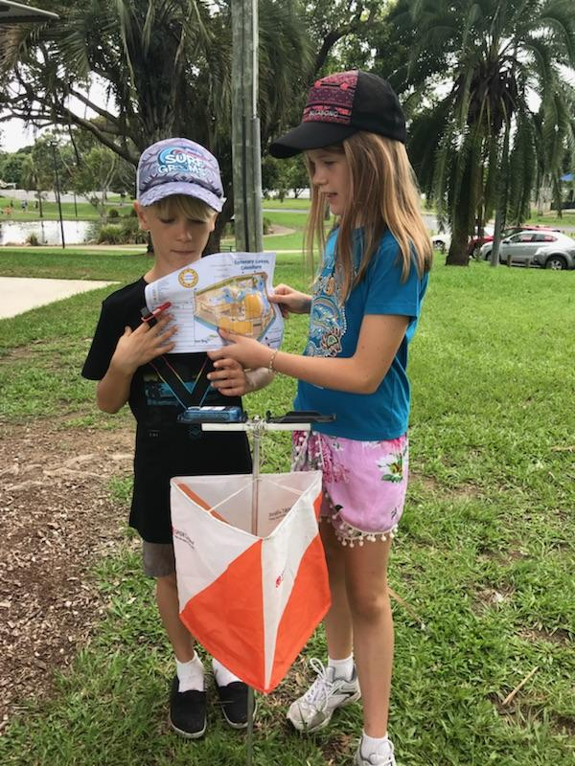
Entry: This event is part of the Orienteering Queensland calendar of events so entry and prepayment is available on the “Eventor” website – linked here.
The “Eventor” website has links explaining how to register an “Eventor” log-in, and how to download the MapRun App (only required on the Long course) and information about available courses and entry fees.

Entry Cost is $5 per person who has their own map. Family members without a map are free. The fees are to cover map printing.

Alternatively, you can enter and order a map by emailing Sunshine Orienteers by midday Friday 4th March.

Courses available
- Novice – 1.2 km
- Moderate Short – 2.4 km
- Moderate Long – 5.0 km (Requires a mobile phone with MapRun App)

Mail to: sunshineorienteering@gmail.com
Enquiries to the Organiser – Mark Petrie – 0429 899 928
Spare maps will be available for Novice entries on the day.
Find us also on Facebook or https://oq.orienteering.asn.au/

