Mountain Bike Orienteering: RIDE-NAVIGATE-RACE

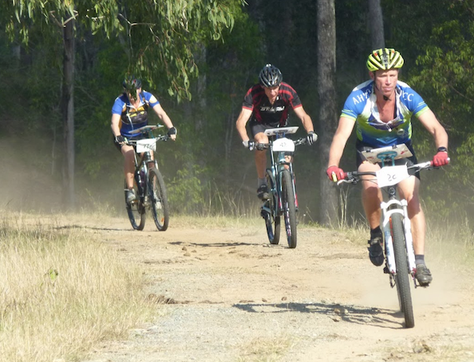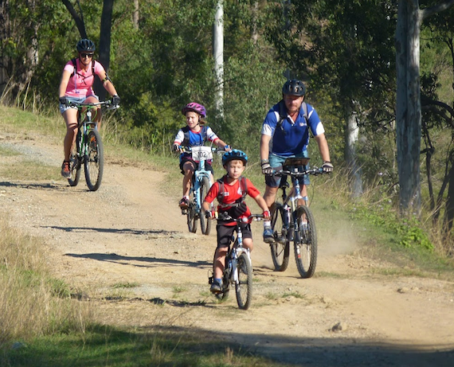

SUN 14th August: Beerburrum West SF via Elimbah. (State Series 6)

On a mountain bike, in a forest, with a map, compass and sense of adventure to find targets in the forest. Ride Solo, in a team or as a family.

Choose your course.

Course | Age groups | Approx Length
1 | Long, M21 | 24 km
2 | W21, M40, M20 | 20 km
3 | Medium, M50, W40 | 18 km
4 | M60, W50, W20 | 16 km
5 | Short, M14, M16, W13, W5 | 12 km
Social score 90 min | Solo riders and teams
Long Score 3 hour | Solo riders and teams

Entry: Enter by Thursday 11/8/2022 midnight
(https://eventor.orienteering.asn.au

Cost: Members: Child $10 / Adult $15 Non Member: Child $15 / Adult $25
Score Courses: Children under 14 free if with an adult

Equipment: Mountain bike, Map board ($10 hire), Sport ident stick ($5 hire or $90 purchase).

Enquiries: info@sunshineorienteers.com.au

