Orienteering Social at Coles Bay on June Long Weekend.

After your sizzling night run around Coles Bay, join all those likeminded hungry people for a bite to eat at Iluka Tavern to mull over your run and the night life seen around the course.
I will book a long table at the Iluka Tavern for Saturday night from 7pm. Please email janemcalder@bigpond.com or phone 62278649 by Friday 5th June, if you want to be included. The Tavern needs to know numbers so they have enough staff to serve us. Everyone is invited.

…and on the same night enter the…

BEST NOODLE/(worst leg) EVER COMPETITION
(hopefully at the tavern during dessert)
- 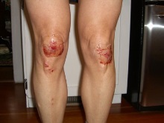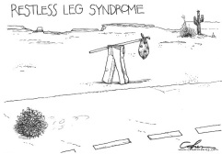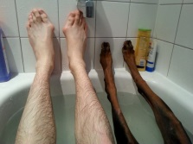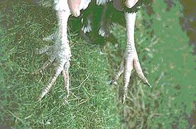

NO NOT THAT SORT OF LEG!!!!!!!

To entertain us all, be prepared to stand up and explain the BEST NOODLE in any course YOU have ever made. You will need to verify your ‘noodle’ with a map or some other evidence. You will be given a short time to speak about your leg, the more humorous the better. Entries will be voted upon by those in attendance and those with the most votes will be awarded a prize. Come along prepared to raise a laugh or many and claim bragging rights for the best noodle of a Tasmanian orienteer!

Hairy legs, non-hairy legs, legs clad in colourful leggings or even grass seeds do not count!

For those who would like to, email janemcalder@bigpond.com a named copy of your map, with or without the noodle and I will organize a PowerPoint slide so you can refer to it in the telling of your BEST NOODLE EVER (assuming the technology works!). You could also bring your map along on a memory stick on the night.

Come on everyone, all ages – put your best noodle/worst leg forward.

There will be HUGE PRIZES …. and a TROPHY!

