Eventor Entry Guide

Go to the Australian Eventor website
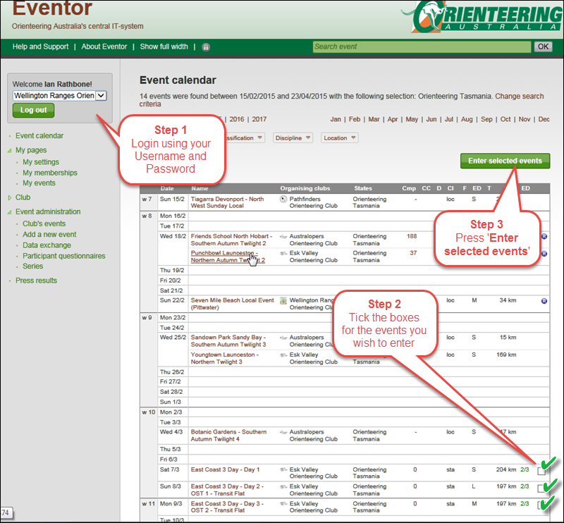

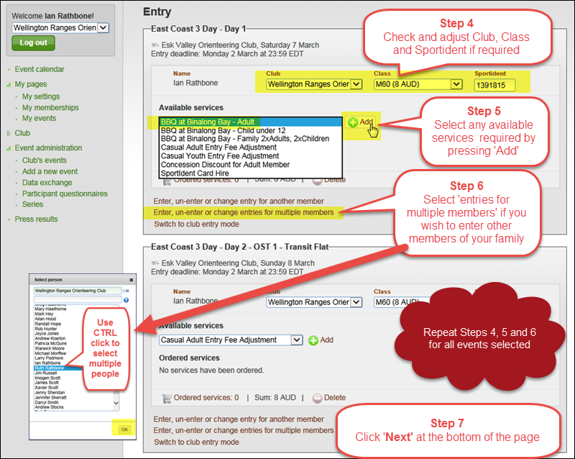
Please note that in Step 5, all casual members need to select the casual fee adjustment listed under ‘Available Services’.
