Eventor Entry Guide

Go to http://eventor.orienteering.asn.au/Events?organisations=8 for Tasmanian events
or http://eventor.orienteering.asn.au/Events for all Australian events
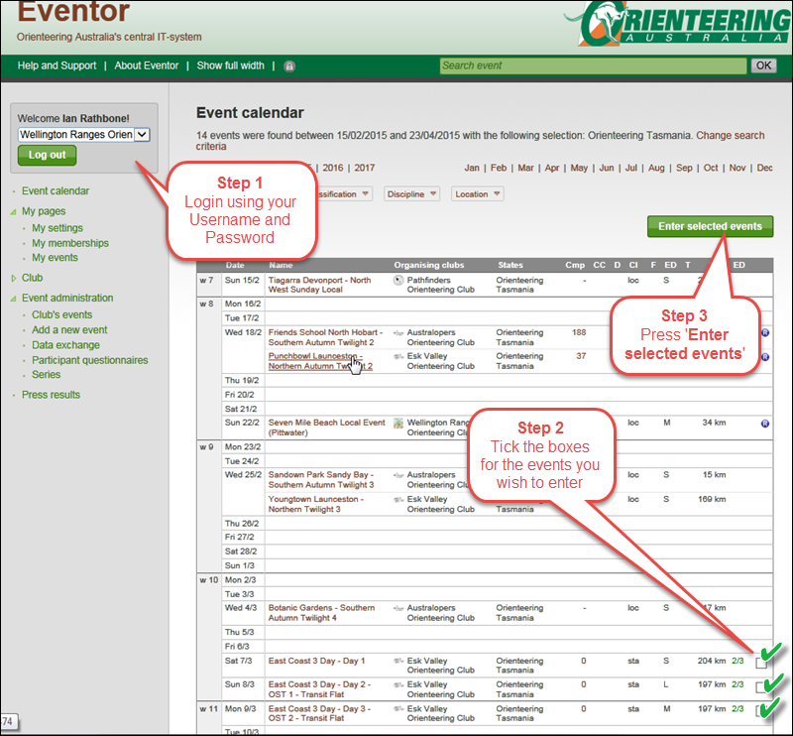

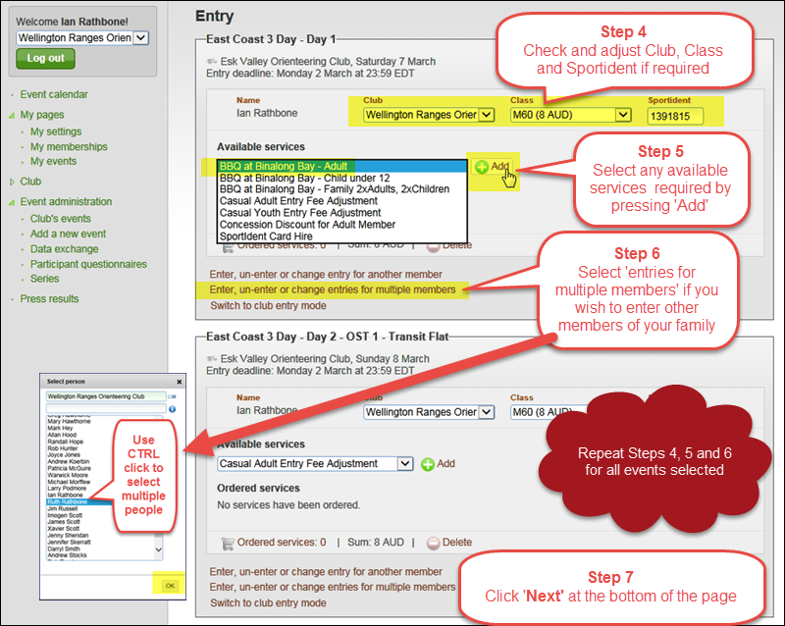
Please note that in Step 5, all casual members need to select the casual fee adjustment listed under ‘Available Services’.
