Snows Hills State League #4 – April 14 2024
Event Program

Directions:
(From Sydney) Drive along the M31 past Campbelltown to Marulan. 2km past Marulan, exit onto Jerrara Rd and follow to Bungonia, then Oallen Ford Rd to Sandy Point Rd. Turn right into Sandy Point Rd and follow for 16.5km until reaching Mayfield Rd. Turn left & drive another 4 km before turning left onto Mayfield Cross Rd. Drive carefully and park on the side of the road once you reach the parking.
It's 60 mins from Marulan. The last 15km is gravel with some fords.
(From Canberra : 1 hr 20min) Drive through Bungendore on the Kings Hwy. 31.5km past Bungendore turn left onto Mayfield Rd. Drive 16km on gravel and turn right onto Mayfield Cross Rd. Drive carefully and park on the side of the road once you reach the parking.
Assembly GPS coordinates -35.216461, 149.796849
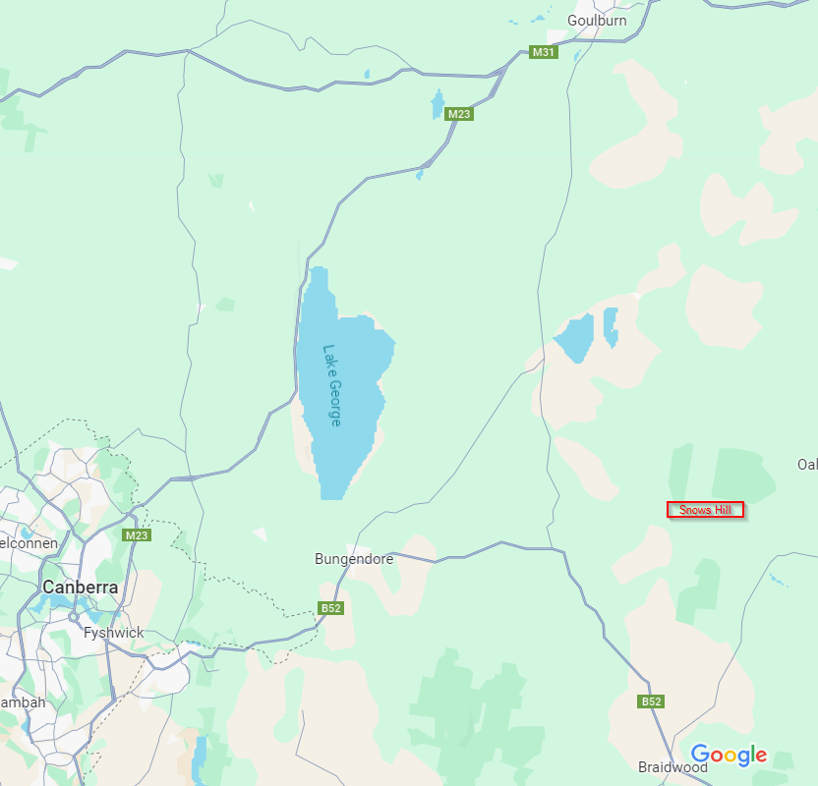
We are on WaterNSW land adjacent to the Shoalhaven River. Access was granted on the condition no dogs or fires are allowed.

Accommodation: Goulburn or Braidwood have plenty of accommodation options. There may be some at Tarago or Bungendore too. Free camping is available at Stewarts Crossing on the Shoalhaven River, 10km east of the assembly area & 15 minutes drive away.

Terrain description: Snows Hill has a wide range of vegetation: open forest, thicker scrub and patches of dense she oak forest. There are both flat and steep sections with good contour detail and many termite mounds. Courses are set to the long distance standards with route choice and physical challenges. It’s one of the most interesting gully spur maps in the country with very difficult navigation for the longer courses. Sections of low visibility and vague areas will make it tricky.

Course | Scale | Classes | Distance | Climb
Hard 1 | 1:15 000 | M21A | 10.8km | 200m
Hard 2 | 1:15 000 | W21A,M20A,M35A,M40A | 8.0km | 180m
Hard 3 | 1:10 000 | W35A,W20A,M18A,M45A | 6.8km | 135m
Hard 4 | 1:10 000 | W18A,W40A,W45A,M16A,M21AS,M50A | 5.7km | 125m
Hard 5 | 1:10 000 | M55A, M60A, M65A, W50A, M35AS, EOD-Hard | 5.0km | 110m
Hard 6 | 1:10 000 | M70A, W16A, W55A, W60A, M45AS, W21AS | 4.3km | 105m
Hard 7 | 1:10 000 | M75A, W65A, W70A, M55AS, W35AS, W45AS, W55AS | 3.3km | 90m
Hard 8 | 1:10 000 | M80A, M85A, W75A, W80A, W85A, M65AS, W65AS | 2.6km | 45m
Moderate | 1:10 000 | M14A, W14A, M-Junior B, W-Junior B, M-Open B,  W-Open B, EOD-Moderate | 2.4km | 75m
Easy | 1:10 000 | M12A, W12A, Open Easy, EOD-Easy | 1.6km | 45m
Very Easy | 1:10 000 | M10A, W10A, M/W10N, Open Very Easy, EOD Very Easy | 1.3km | 40m

Mapper’s Notes: Over the last few years the vegetation in the mapped area has got thicker and it has been revised on the map but only in the parts that are used for this event.
There are a lot of termite mounds on the map and some of these have been checked during the remapping of the vegetation but not all of them. It was found that the majority are correct with more missing ones than new ones. Where controls are placed on termite mounds these and surrounding ones have been checked.
Easy & Very Easy Courses: There are streamered routes on most but not all legs of the M/W10 & M/W12 courses. Please check your control descriptions carefully.
Safety Directions: Snows Hills has few tracks. If you are very lost you are best heading north or northwest to the fences & gravel roads on the edge of the map.
Assembly: The assembly area is above the Mayfield Cross Rd where you will park. There is a barbed wire fence which we will pad for you slip through. The wires are very tight and you will have to take care. Access to the start is back across the fence and NE along the road.
Starts: The start is an easy 500m walk from the assembly. Allow 10 minutes as you will have to cross the fence. There is no water provided, nor toilets or clothing return. You may warm up along the fence but not go into the forest past the prestart. Queuing starts are available from 9.30am until 11.00am. Control descriptions are available loose at the prestart and on the map
Start Procedure: It’s a punching start with 2 minute intervals. Hard 1 & Hard 2 courses will use the same start lane as there are fewer entrants on these courses.
Course Closure: Courses close at 1.30pm, so unless you are injured or abducted by aliens, you must report to the finish before that time. If you anticipate spending more time enjoying your course, please get an early start.
Download: The download tent is near the finish. Please ensure you download whether you completed your course or not.
Results: Will be printed out and displayed near the download tent. Online access is not possible at the event.
Water: Is provided on all courses longer than 4km. You are welcome to carry your own water. There is no water provided for before or after your run. Please bring your own.
Facilities: There will be 2 portaloos on the road near the assembly
Catering: The NSW Junior Squad will be selling drinks and baked goods, but there will be no BBQ or meals available (contrary to originally advertised). There are no nearby shops, so bringing your own lunch is recommended!
Enter on the Day: Is limited to Easy, Very Easy, Moderate and the Hard 5 course.
Phone Coverage: Is very limited. Even Telstra is patchy

