# 

**Multi Terrain Bike Orienteers**

Woodford MTBO

**Sunday 19th May 2024**

**Welcome to MTBOs Woodford event. The meeting point is the Woodford Mens Shed.**

**Road Directions:**

From South, take the Bruce Highway north after the Gateway Bypass intersection until near Caboolture. Take Caboolture/Kilcoy exit 152B from M1 and follow the D’Aguilar Highway (Route 85) to Woodford (25 km). At Margaret street, turn right and then immediately turn right at the 1st cross street onto Archer St Service Rd. The Mens Shed is in Victoria Lane which will be the first left.

From the North, take the Bruce Highway south to near Caboolture. Take Caboolture/Kilcoy exit 152 from M1 and follow the D’Aguilar Highway (Route 85) to Woodford (25 km). At Margaret street, turn right and then turn right at the 1st cross street onto Archer St Service Rd. The Mens Shed is in Victoria Lane which will be the first left.

*Alternatively* if coming through from Beerburrum on Beerburrum Woodford Road, there is a left turn when the road becomes Golf Course Rd. Turn right onto George St. Turn left onto Hendy St. Hendy St turns right and becomes Margaret St. Turn left into Archer St Service Rd. The Mens Shed is in Victoria Lane which will be the first left.

Parking is available in and around the Men’s Shed building and on the road side leading into the shed.

**Registration**

The registration desk will open at 8:15am.

All competitors are required to check in at the registration desk, collect a timing stick and pay any entry outstanding entry fees.

For newcomers, basic instruction will be available from our friendly club members at rego.

You’ll be able to hire a mapboard at registration and get help to mount it. It makes all the difference for holding your map on your handlebars.

You can also hire Sportident timing stick at registration, if you didn’t hire one upon entry.

**Terrain**

This is plantation pine forest, with some small patches of native and open grassy areas. Lower areas around watercourses can be wet with slow to difficult riding. Open grassy areas can be slow to difficult to ride due to high grass and numerous animal tracks.

Higher areas are affected by lantana growth. Tracks with heavy grass growth will require keen observation and distance estimation to their intersections.

The gradient of the area varies from gently undulating to a few steep areas. Roads are mainly firm and grassy, with some adjoining watercourses, muddy and wet.

**Map**

**Scale and Contour Interval**

Scale 1:15,000. 1cm=150m. Contour interval 5 metres. The maps will be A3 size.

**Timing**

|  |  |
| --- | --- |
| 8.15 | Rego opens |
| 8:30 | Start Opens |
| 10.00 | Start Closes |
| 12.00 | Courses Close |

**Key Personnel**

Course planner: Dave Congreve

Event Organiser: Athol Lester

**Courses**

|  |  |  |
| --- | --- | --- |
| **Courses** | **Km** | **Classes** |
| Course 1 | 27 | Men Open, Social Long, Women Open Long |
| Course 2 | 24 | Women Open, Men 40-49. Men 17-20 |
| Course 3 | 22 | Men 50-59, Women 40-49, Social Medium |
| Course 4 | 19 | Men 60+, Women 50-59, Women 17-20 |
| Course 5 | 12 | Women 60+, Men 14-16, Women 14-16, Social Short |
| Score | 2Hrs | Solo riders and teams |

For Courses 1-5, you must get the controls in the order specified on the map (Start, 1, 2, 3… Finish).

For the Score course, you can visit the controls in any sequence in order within the 2Hr time limit. The course close time also applies.

**Course Closure**

Courses close at 12:00noon. If you have not finished your course by this time, please abandon it and return to the Finish control and then the Download desk.

**Out of Bounds Areas**

Areas of private property bordering the event area are off limits.

**Map Notes**

The site has many features, natural and man-made, but in order to make the map readable at the scale we’re using, it wasn’t possible to show everything.

Please also note that grass grows, trees fall and tracks are occasionally bulldozed or slashed. These things are beyond the mapper’s control.

**Special Rules for this Event**

Riding across Rough Open land (yellow area symbol) is permitted for this event.

**Road and Track Grading**

The maps have been prepared to the IOF standard for MTBO maps with the exception that we are using the Australian 2 x 4 track grading system, briefly explained below. If you are unsure about the track grading system, study the map legends available at rego. If you have any questions, please ask of our helpers.

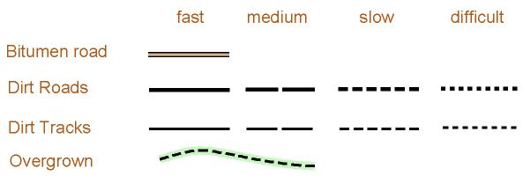

**Fast** – little or no restriction to the speed which a rider can attain. Generally, these are tracks that would be suitable for a standard 2WD vehicle. Roads shown as a wide full line, and tracks as a narrower full line.

**Medium** – generally good riding with some reduction in speed and a requirement to keep an eye on where you are going to avoid obstacles such as potholes, rocks, ruts, sand, vegetation etc. Generally, these are tracks that would be suitable for a light 4WD vehicle. Roads shown with a wide line and a long dash and tracks with a narrower line and a long dash.

**Slow** – sufficient obstacles to require the rider to pick lines to avoid obstacles. Consistently potholed, rocky, rutted, vegetated or sandy. Soft surface due to standing water. Skilled, fit riders should be able to ride almost always. Less skilled and fit riders may have to dismount. Roads shown with a wide line and a short dash and tracks with a narrower line and short dash.

**Difficult** – a technical track/path which may require the rider to dismount. Skilled, fit riders may be able to ride without dismounting.

**Overgrown** – track existed at some earlier stage to a standard indicated by the black line symbol, but may be obscured by plant growth.

**Safety**

If you encounter an injured rider, you **MUST** abandon your course and render whatever assistance you can. Send another rider back to registration for assistance, if possible. Please keep alert and ride to the conditions. You must obey all road rules and are fully responsible for your own safety.

The emergency contact at the assembly area is Craig on 0418871193.

Hazards on this course may include: -

* fallen trees
* potholes and erosion gullies
* long grass
* wildlife
* cyclist, runners, walkers
* motor bikes, vehicles and trucks

**Rules**

<http://www.mtbo.com.au/mtbo_rules.pdf>

The Australian MTBO rules shall apply to this event. These can be found on the [MTBO Club page](http://www.mtbo.com.au/mtbo_rules.pdf). All competitors are urged to read and understand these rules. Some key items include:

* All competitors must wear bike helmets.
* Competitors must stay on the tracks marked on the competition map. If terrain or road conditions force the rider to dismount, they must carry the bike on a marked track. No off-road shortcuts through the bush are permitted.
* Competitors on normal courses must visit the control sites in sequential order. Check the control number on the marker is the same as the one on your map before punching.
* Competitors must not become separated from their bike during a competition, unless through injury or mechanical failure.
* Courtesy and sensible behaviour are expected when mountain bike riders encounter walkers, runners, horseback riders, land-owners, forestry workers, or logging vehicles during an event.
* Competitors and officials must avoid disturbing local flora, fauna and stock at the event and respect the local environment.
* Practice and observe the rules of the road – keep to the left on roads and tracks.
* Approach all track/road crossings, corners and hillcrests with caution.
* Ride defensively and in control at all times.
* Give way to faster riders wishing to pass on narrow tracks
* Riders going downhill should give way to riders going uphill
* Calling out to other riders, sharing information about control locations, or seeking assistance with regards to your location, will bring instant disqualification. If you see or hear any of this behaviour, report this to the organiser.
* Give assistance to injured competitors on the course. Organisers may give a restart or organiser points for the rider who gave assistance.

**Map Symbols**

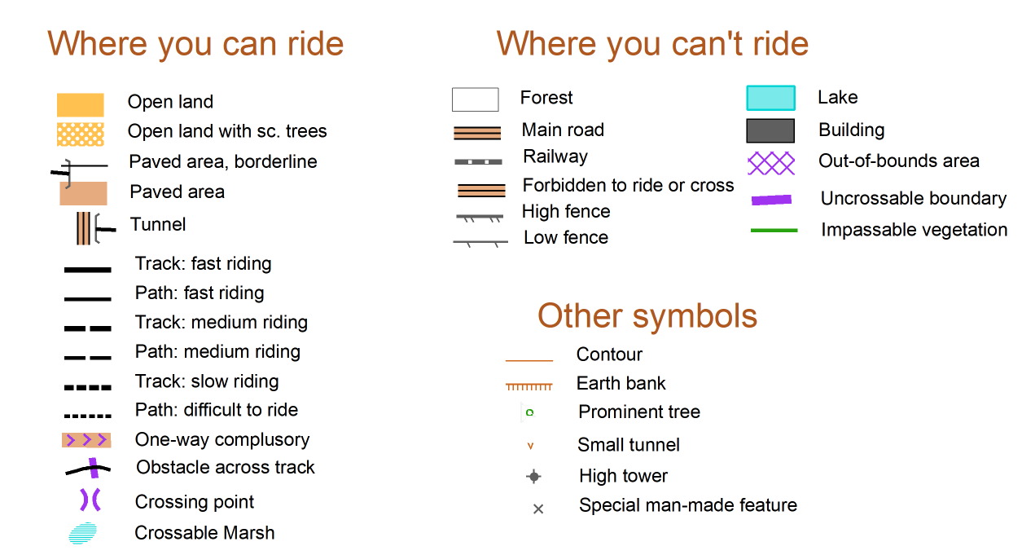

**SPORTident**

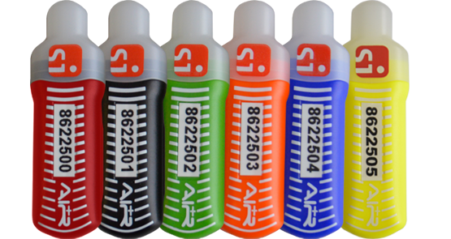

This event will be using the SportIdent Electronic timing system.

**SPORTIDENT Air Contactless Punching**

Familiarise yourself with how the system works by reading the guides that we’ve sent to you.

**SPORTIDENT use on the Course**

If a SPORTIDENT unit at a control malfunctions and does not “beep” or “flash” when the stick is inserted, the competitor must use the red pin punch at the control to mark their map. Failure to do this will result in a DNF being recorded. If you need to use a punch at any control, please advise the Finish officials as they will need to sight your punch map, to confirm that you have completed the course.

**Control Flags**

Standard orange and white control flags will be suspended on pickets with an SPORTIDENT unit and red pin punch (for use if the control units fail). The control identification number will be the SPORTIDENT unit. This will match up with the control number on the map. If you accidentally punch the wrong control, continue on to your correct control and proceed as normal. Punching a control more than once will not gain you any extra points.

**Clear & Check**

It is important to remember to “clear” and “check” your SPORTIDENT stick prior to each stage, to delete previous event information stored on it. Special “Clear” and “Check” units will be positioned in the pre-start area of each event. It is the competitor’s responsibility to ensure that they have the correct SPORTIDENT stick and that it is cleared of previous race data before they start. If you do not clear your SPORTIDENT stick it may not have enough memory to record all your controls.

**Water**

Everyone is urged to drink plenty of water before starting their ride. Please bring your own water for use before and after the event.

**Facilities**

There are toilet facilities at the Mens’ Shed building.

**Start**

After you register, you can start whenever you’re ready.

There are no pre allocated start times. You may start at any time during the starting window.

Note: you must Clear and Check your SPORTIDENT Air stick, as this wakes it up. There will be a Test unit after the Clear and Check to test your SportIdent Air stick has turned on.

After you’ve been given the start signal, you may choose to spend a few minutes deciding on which route to follow. Just move aside so you don’t obstruct other starters.

TIP: take it slow to your first control point, to get a feel for how the scale of the map relates to actual distances on the ground.

**Finish**

At the finish, riders must punch or wave one of the “Finish” controls to end their event and record a finish time. After punching the finish control, proceed to the download desk to download your results and receive your time and we’ll retrieve your SPORTIDENT stick.

For safety reasons, all riders must report to the finish and then the download desk to indicate they have returned safely, irrespective of what time they return, to avoid search and rescue procedures. DO NOT GO HOME WITHOUT DOWNLOADING.

Tip: The Finish control turns off your SPORTIDENT Air stick, so you must go there to end your ride and conserve its battery.

If you’ve enjoyed yourself, then please consider helping us out by retrieving a couple of controls before you leave. Put your name down at Rego when you check in.

**Safety**

For any serious medical emergency call Triple Zero (or 112 if you don’t have reception from your usual mobile carrier).

If you encounter an injured rider, you **MUST** abandon your course and render whatever assistance you can. Send another rider back to registration for assistance, if possible. Mobile phone coverage may be limited on the course and assembly area. The emergency contact at the assembly area is 0408 682419.

A first-aid kit will be available in the assembly area for emergencies. There will also be a trained first-aider in the assembly area.

Hazards on this course may include fallen trees, potholes, long grass, wildlife, horse riders, motor bike riders, vehicles and trucks on public roads, 4WD’s. Please keep alert and ride to the conditions. You must obey all road rules.

We recommend and use the Emergency + App, to assist Emergency Services to locate you…



Android - <https://play.google.com/store/apps/details?id=com.threesixtyentertainment.nesn&hl=en_AU>

Apple - <https://itunes.apple.com/au/app/emergency/id691814685?mt=8>

**Event Results**

Placings and Split Times will be available in Eventor and our club website shortly after the event… [**www.mtbo.com.au**](http://www.mtbo.com.au)

**Anything Else?**

Contact Athol Lester on 0408 682419

