**PRE-CHRISTMAS TRAINING**

**ORIENTEERING TRAINING FOR ALL**

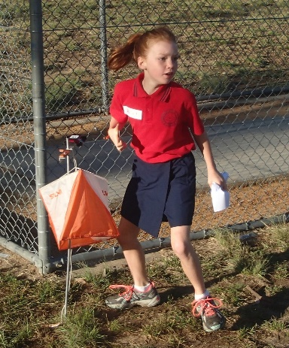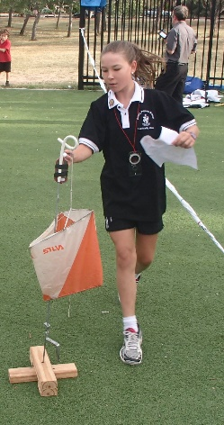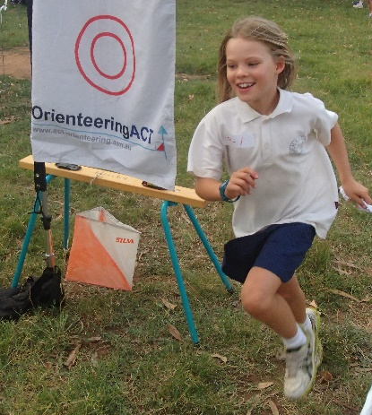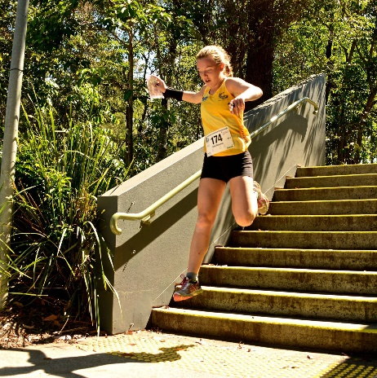

**7 sessions over 5 days**

**Saturday 14 December to Wednesday 18 Dec 2024**

Structured group learning for confident navigation – in urban environments and bush environments.

Compass use, contours, landscape, and feature identification, as well as understanding the usefulness of fitness and focus and race skills for the more serious.

All sessions will take place in and around central Canberra.

Sessions will be aimed at those current participating in “Easy” level orienteering and above, with a particular focus on those on “Moderate” wanting to consolidate their Moderate Level Skills.

There will be a strong focus on creating social links with other like-minded ‘wild runners’.

If you have completed Learn to Orienteer, or you are ‘mastering’ basic navigation as part of the SC-ORE School Orienteering program, then these sessions could be for you.

BUT you must be 11 years or older AND if you are in Primary School, you will need a parent/guardian to remain throughout the sessions.

Detailed program, including session times and locations to be confirmed. Session times may be adjusted in the cases of extreme weather conditions.

Cost: $40 per participant ($80 per Family - must include at least one adult).

For more information email [totoni@iinet.net.au](mailto:totoni@iinet.net.au)

Training by [Orienteering ACT](https://act.orienteering.asn.au/) and in collaboration with [Goldseekers Orienteering](http://goldseekers.org) and [Bold Horizons.](https://www.boldhorizons.com.au/)

