TOOHEY FOREST ORIENTEERING ASSOCIATION brings you
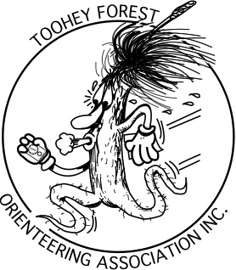
Don’t get lost!
Learn to Navigate
in Bushland
Same location each week

Session 1 Sunday 7 February Stockyard Creek, Brisbane Koala Bushland, Alperton Rd. Burbank
Basic map reading, using map and compass together
Session 2 Sunday 14 February Stockyard Creek, Brisbane Koala Bushland, Alperton Rd. Burbank
Using handrails and attach points
Session 3 Sunday 21 February Stockyard Creek, Brisbane Koala Bushland, Alperton Rd. Burbank
Route choice on the move, how the best do it!

Assembly 1pm each session One hour instruction followed by a practise navigation course
Cost per session Adults $8, Children $5, Family max $20. (Members discount $2)
Register for this activity by emailing tfo.secretary@gmail.com
Or phone Rob Simson 33454527

*** This program is open to beginners as well as orienteers and rogainers wishing to improve their navigation competency. Families are welcome. Children from seven years are ready to learn the basics.

*** Regular orienteers just interested in a social outing may undertake an easy course (1.5km), moderate course (2.5km) or hard course (3km or 4.5km) starting after 2pm. This will be on a friendly honour system like mid-week orienteering. Sport Ident will not be used.

Note: This coaching program is not about switching on your GPS, but about reading maps effectively with the help of the compass for map orientation and direction.

