Relay weekend Feb 12 and 13
Christoph has planned 3 relays for next weekend, they should be fun as they are different to our normal relays. The reason for this special bulletin is that he must have your entries by this Sunday. There is no need to find team members – they will be allocated. Pay on the day, there is no charge for the 3rd event.
We kick off with a sprint relay on Friday evening around Bellerive Fort, there is a mass start at 6:15pm and each runner runs twice. There will 21 controls out there, so it will be fast and furious.
On Saturday morning we move to Pittwater. You will be in a team of three, all of you leave together and you all must punch the compulsory controls. In addition, there are a large number of other controls which must be punched by someone in your team. Your team decides who punches what, and you all cross the finishing line together.
On Saturday evening there is a beer/beverage relay at the Butlers house (4 Wentworth St Bellerive), followed by a BBQ. It is a fun event run in 2 divisions – beer drinkers and others. There will be drinking cups supplied, so you could even drink water and be legal. Two persons per team and each person runs 3 times – about 1.5km each time. There is no charge to participate in this event and you can turn up just for the BBQ if you want. Bring your own food and drink to the BBQ.
All we need you to do is register your intention to participate by this SUnday by emailing Christoph (Christoph-prunsche@web.de). Why not do it now?
Full details from Christoph are below.
Mike Calder.

Relay-Weekend
Entry: Via mail to christoph-prunsche@web.de until Sunday, 07.02.!
Including:
- The competitions you want to enter for
- Your SI-number
Costs:
Event Fees | Adult | Adult | Youth or  Concession | Youth or  Concession | Family |  | Family
 | Casual  Member | Full  Member | Casual  Member | Full  Member | Casual Member |  | Full  Member
Local event | $12 | $8 | $6 | $4 | $30 | $20
We will collect the money at the competitions. No charge for the third event.

Friday, 12.03.16
2-man-sprintrelay at Bellerive Fort – some special orienteering!
Competition Centre: Parking place at Bellerive Fort
What are the rules?
- Each team consists of two runners
- Mass start for first runners, each runner runs twice
- No forkings
Map: Bellerive Fort, 1:3.000 / 1,5m
Course Length: 1,8km / 1,6km
Time Schedule:
- 5 pm: CC at Bellerive Fort opens
- 6 pm: demonstration of the relay
- 6.15 pm: mass start

Saturday, 13.02.16
Team competition at Pittwater – classic German competition!
Competition Centre: At the end of Centre Road
What are the rules?
- Each team consists of three runners, starting and finishing together
- We will allocate the teams
- Each course consists of “normal” controls (numbered A -…) that have to be punched by EVERYONE and in the RIGHT ORDER
- Moreover there are a big number of “special” controls (numbered with code numbers). They can be divided between the three runners (see example below), but in the end each team needs all of the controls on the map to not be disqualified
- The first control that has to be punched by all three team members is NUMBER A! There might be “special” controls on your way to A, but you can’t punch them before punching A otherwise you’ll be disqualified
- Some tips: Normally two runners of the team lead the team to control number A, while the third one tries to split up the controls for each of the runners. After punching A, we normally sit down and take some time to distribute all controls and to not forget one. The one planning the course normally does it like this: “Runner A, you take 31-33-35-B-45-C-…” . After runner A got all his controls, he can start to collect his controls. Then the same for runner B and runner C (the one planning) takes the rest. Generally there are two tactics for the race: distributing all controls at number A and then just meet in the end at the last control (advantage: no more time losses due to waiting times during the race or changes in planning / disadvantages: no control if really all controls are distributed; if a runner doesn’t feel good no chance of changing your tactic) or just distribute the controls until a new meeting point (the first one there would start planning the rest of the course and, if the second runner arrives, check with him if they collected all controls more safety, but can be slower)

- What makes this so exciting?
You have to know your team members, as different people have different strength/weaknesses and you have to have those in mind while distributing the controls. Moreover a lot can change during the competition and normally you never can be a 100% if your team has all the controls until you read out in the finish. It’s just fun!
Map: Pittwater, 1:7.500 / 2,5m
Length: 4km
Time Schedule:
- 9 am: CC at Pittwater opens
- 10 am: First start
- 1.30 pm: Finish closes
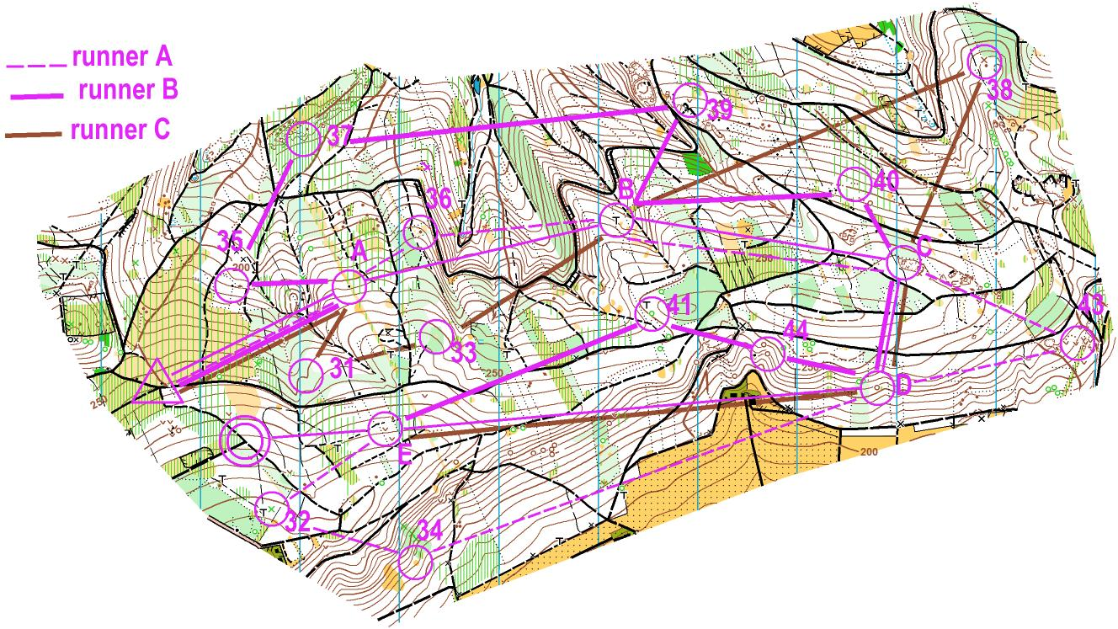
Saturday, 13.02.16
Beerrelay at the Butler’s house – time to have some fun!
Competition Centre: The Butler’s house, parking somewhere in Wentworth St
What are the rules?
- There are two classes: beer-class (aged 18 or older) and non-alcoholic class remember to not drive after you’ve drunk!
- Every team has to bring their own beer (preferably cans: 6/team) and non-alcoholic drinks (6/team)
- Each team consists of two runners
- Each runner has to run three short courses around Wentworth Park and the Butler’s House
- There will be a mass-start: before getting their maps each first runner has to drink a beer/ non-alcoholic stuff and then starts on his first round. When he comes back the second runner has to drink as well, starts on his first round and so on…
Map: Wentworth Park, 1:5.000 / 1,5m
Length: 3* 1,5km
Time Schedule:
- 6 pm: CC opens
- 6.45 pm: mass-start
- During and (especially) after the beerrelay we will have barbecue! So please bring some stuff to drink and eat! And even if you don’t want to run…just come along!

