2016 AUSTRALIAN MOUNTAIN BIKE ORIENTEERING CHAMPIONSHIPS NATIONAL MTBO SERIES #3

Saturday 15 October 2016 – Sprint Distance, Dwellingup, WA; Saturday 15 October 2016 – Middle Distance, Marrinup, WA; Sunday 16 October 2016 - Long Distance, Murray Valley, WA

BULLETIN 1

Event Director: Ricky Thackray rickythackray@hotmail.com
Organising Committee: Duncan Sullivan, Ori Gudes, Natasha Sparg
Event Controller: Jack Dowling
WELCOME
Welcome to Bulletin 1 for the 2016 Australian MTBO Championships
These Championships are organised by Orienteering WA.

Championships website
ausmtbochamps.com

VENUES
All Championship events will be held within a short drive of the town of Dwellingup, WA.
The area is known for its natural bushland, multitude of walking and riding tracks (including being a crossing point for both the Bibbulmun and Munda Biddi trails) and is a terminus for the Hotham Valley railway.
The event centres are less than 90 minutes' drive from Perth airport.
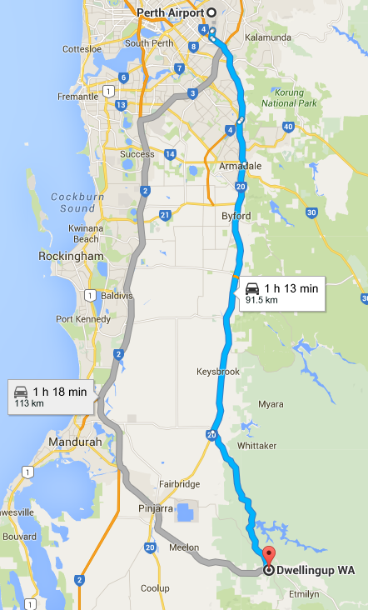
Program
Fri 14 October | afternoon | Warm-up event | Turner Hill
Sat 15 October | morning | Sprint Distance Championship | Dwellingup
Sat 15 October | afternoon | Middle Distance Championship | Marrinup
Sat 15 October | evening | Presentation Dinner | Dwellingup
Sun 16 October | morning | Long Distance Championship | Murray Valley
National MTBO Series
The three Australian Championship events comprise the third round of the 2016 National MTBO Series for Junior, Senior and Masters classes.
More information on the series on this link.
http://tinyurl.com/natmtboseries
WA MTBO Championships
The middle and long championships will also constitute the 2016 WA MTBO Championships. These titles will only be eligible to Orienteering WA members.

EVENT DETAILS
The Turner Tester – a champs warm up event
Date: Friday 14 October 2016 (afternoon, likely from 1pm)
Event Assembly: Turner Hill trailhead

2016 Australian Sprint Distance MTBO Championship
Date: Saturday 15 October 2016 (morning)
Event Assembly: Dwellingup (TBA)

2016 Australian Middle Distance MTBO Championship
Date: Saturday 15 October 2016 (afternoon)
Event Assembly: Dwellingup golf course (Marrinup, TBC)

2016 Australian Long Distance MTBO Championship
Date: Sunday 16 October 2016 (morning)
Event Assembly: Baden Powell picnic area (TBC)
TECHNICAL INFORMATION
Australian MTBO competition rules will apply to all events.
SportIdent
SportIdent timing will be used for all events. All competitors will be required to use a SportIdent tag. If you don’t own one, they will be available for hire when entering on Eventor under the Additional Services menu for $3 per event.
Maps
The sprint and middle distance championship maps will be mapped by Duncan Sullivan. The long distance championship map will be mapped by Ricky Thackray. In addition the warm up event map has been updated in 2015 by Ricky Thackray. All maps will use the IOF standard 4x2 track system and will conform to current IOF specs, with some deviations relating to forest colours.
Please note that during these events, it is only permitted to ride on tracks which are marked on the map or on open areas of ground shown which are shown on the map as open land (100% yellow) - symbol 401 - or open land with scattered trees - symbol 402.
No MTBO events have been previously held in these areas (other than the warm up event) and there are no existing orienteering maps, other than for Turner Hill, which will be placed on the website in due course.
Championship Age Classes (STC)
 | Long Distance | Middle Distance | Sprint Distance
Course 1 | M21 | M21 | M21
Course 2 | M40, M50 | W21, M17-20, M40, M50 | W21, M17-20, M40, M50
Course 3 | W21, M17-20, M60 | W17-20, W40, M16, M60 | W17-20, W40, M16, M60
Course 4 | W17-20, W40, W50, M16, M70 | W50, M70 | W50, W60, M14, M70
Course 5 | W14, W16, W60, M14, M80 | W14, W16, W60, M14, M80 | W12, W14, W16, W70, W80, M12, M80
Course 6 | W12, W70, W80, M12 | W12, W70, W80, M12

• For those not wishing to ride in the Championship (age) classes, there will be a “Recreational” Open Class on Courses 2, 4 & 5.
• Participation in Championship classes is restricted to members of IOF recognised orienteering associations, including all Australian state orienteering associations and affiliated clubs.
Course details
Course lengths and elevations will be included in a later bulletin.
Below is a guide (in minutes) of what the expected winning times will be for the various age groups.
 | Long |  | Middle |  | Sprint
 | Men | Women | Men | Women | All
Elite | 105 - 115 | 85 - 95 | 55 - 60 | 45 - 50 | 20 - 25
Masters | 105 - 115 | 85 - 95 | 55 - 60 | 45 - 50 | 20 - 25
Juniors | 84 - 92 | 68 - 76 | 44 - 48 | 36 - 40 | 16 - 20

EMBARGOED AREAS
The following areas are embargoed until after 16 October 2016 for competitors wishing to compete in the 2016 Australian MTBO Championships.

For the Sprint Championships: Dwellingup north of the townsite.

For the Middle Championships: Areas to the Northwest and northeast of Dwellingup, North of Pinjarra Williams Road as marked including the Marrinup POW camp, old Golf Course, Marrinup Mountain Bike circuit, and Dwellingup township. Participation in organised Mountain bike cross country competition sanctioned by MTBA is allowed so long as no map is carried. Note that staying within Dwellingup is allowable.
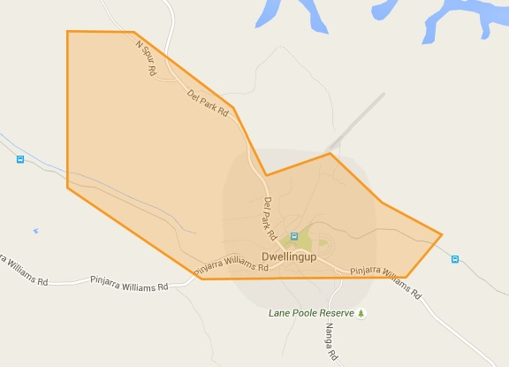
For the Long Championships: Murray Valley bounded by Nanga Rd (to the west), Nanga Mill campground (south), Murray River (east) and River Rd (east and north), unless riding the Munda Biddi.
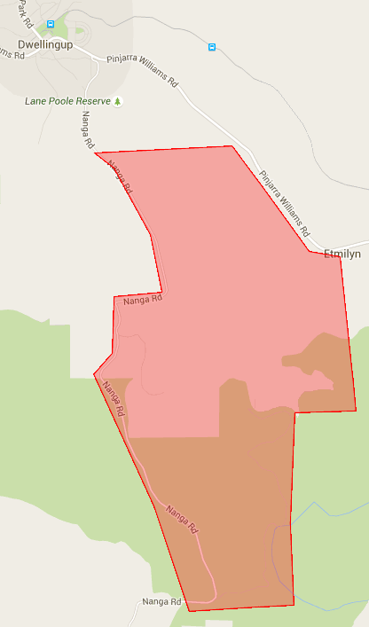

ENTRY
Online entry will be open via Eventor by the issue of Bulletin 2, Orienteering Australia’s online entry system. Payment can be made using Paypal.
Closing Date for entries is 2 October 2016. Later entries will incur a 50% surcharge.
Visit Eventor to enter
Using Eventor
If you are new to Eventor, you first need to register and create a user account.
There is a “Help & Support” section on the main Eventor calendar page if you need assistance.
Pay entry fees in a single transaction
From the Eventor Event Calendar, tick the box on the right for all three events (four if you are doing the Turner Tester) when you enter, and this will produce a single invoice for payment instead of 3 or 4 separate ones.
Entry fees will be announced in the next Bulletin.
SportIdent Hire
All competitors will require their own SportIdent tag. They are available for hire under the “Additional Services” menu on Eventor for $3 per event. Alternatively if you wish to buy your own contact www.aussieogear.com or ph: 02 4384 5003. Alternatively for WA entrants, Tony Simpkins sells these and can be contacted at most events.

EVENT DINNER & PRESENTATIONS
Date: Saturday 15 October 2016
Venue: TBA
Dinner: TBA

ACCOMMODATION
There are various accommodation options in and around the town of Dwellingup but it is not a major town so it is best to book early to get the best deals. Options range from motel accommodation to bush cabins, B&Bs and lodges to camping. Note that several camping and lodging areas (including Marrinup, Nanga bush camp, Dwellingup B&B and the various Murray Valley campsites) are located within some of the courses. Prior arrangement to stay in these areas should be sought from the organiser.
www.dwellingupwa.com.au/home

Bike Shop
There is a store selling a limited range of MTB parts and accessories in the town of Dwellingup. The nearest large specialist cycling stores are located in Mandurah ~50km away. Make sure to pack spares!

SPONSORS
Thank you to the following sponsors and partners for their assistance with promotion and donation of prizes.
Proudly sponsored by Thule  thule.com.au/ | aboutbikehire.com.au | www.bwa.org.au
POST EVENT ADVENTURES
Cape to Cape MTB Race: 20-23 October 2016
The iconic Cape to Cape multi-day MTB race is on Thursday October 20 to Sunday October 23, 2016. Entries are already open and fill up fast so you will need to get in quickly. For further details: http://capetocapemtb.com/
12hr Foot Rogaine: 22 October 2016
The WA Rogaining Association is organising a 12 hour foot rogaine on Saturday 22 October 2016 (location TBA closer to the date). Entries typically open six weeks before the event and close promptly ten days prior - no late or on the day entries accepted! For further details: http://wa.rogaine.asn.au/
Ride the Munda Biddi
For those who haven't had enough adventure but just want to explore, the famous Munda Biddi trail stretches over 1000km from Mundaring (east of Perth) to Albany. Both the Munda Biddi and Bibbulmun trails pass through Dwellingup. Ride it all or choose a stage to do in a day: https://www.mundabiddi.org.au/
http://trailswa.com.au/

