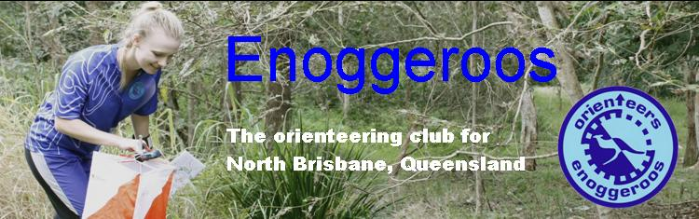

NORTH LAKES

Location North Lakes Map North Lakes - 1:10000 colour
Event type Foot – Park Terrain Park and surrounding streets
Date Sunday 29 May 2016

Starts 9:00am - 10:30am Close 12:00pm

COURSE | LENGTH | CLIMB
Very Easy | 1.4 Km | 0m
Easy | 1.8 Km | 0m
Moderate Short | 2.5 Km | 20m
Moderate Long | 3.1 Km | 30m

Online Entry Opens: 20/04/2016 Closes: Midnight 26/05/16

If you have difficulty entering through EVENTOR please contact the organiser before this date.

Cost Adult $5
Family $15

Please PAY ON DAY

Facilities Toilet . There is also a Cafe there for an early morning coffee!

SportIdent SportIdent will be used, hire fee $2.00

Organiser John Baker

Setter John Baker

Contact person John Baker Contact number 0439774470

Directions –From the south: Proceed north along Bruce Highway (M1) and take the Anzac Av exit to North Lakes. Follow Anzac Av east (Approx 600m) and turn left into North Lakes Drive (Traffic Lights). At the next set of traffic lights (Approx 150m) turn right into Memorial Drive. Proceed along Memorial Drive for 400m to Lake Eden. Look for Orienteering start banner. Parking on the street opposite the Lake and there is a carpark at the café on the lake. From the north: Proceed south along Bruce Highway (M1) and take the Anzac Av exit to North Lakes. Follow Anzac Av east (Approx 600m) and turn left into North Lakes Drive (Traffic Lights). At the next set of traffic lights (Approx 150m) turn right into Memorial Drive. Proceed along Memorial Drive for 400m to Lake Eden. Look for Orienteering start banner. Parking on the street opposite the Lake and there is a carpark at the café on the lake.

