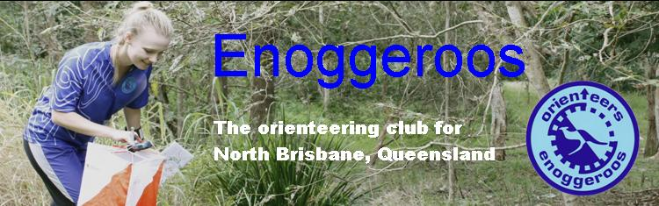

Bluestone Creek OY 5
Location Mt Crosby Map Bluestone Creek - 1:10000 colour
Event type Foot – Bush Terrain Gully /Spur – steep to undulating
Date Sunday 22 May 2016
Starts 9:00am - 10:30am Close 12:30pm
COURSE | LENGTH | CLIMB
Very Easy | 1.6 Km | 50m
Easy | 2.0 Km | 60m
Moderate 1 | 3.1 Km | 120m
Moderate 2 | 2.1 Km | 85m
Hard 1 | 6.8 Km | 290m
Hard 2 | 5.1 Km | 200m
Hard 3 | 3.9 Km | 175m
Hard 4 | 2.8 Km | 115m
Hard 5 | 2.1 Km | 85m
Online Entry Opens: 17/04/2016 Closes: You MUST PRE ENTER by 19th MAY to get a map.

If you have difficulty entering through EVENTOR please contact the organiser before this date.

Cost Type (member/non-member)
Adult ($12.00/$18.00)
Junior ($8.00/$12.00)
Family ($36.00/$54.00)

There are No toilets at the assembly area. The nearest toilets are approximately 2k east at Colleges Crossing Rec Reserve. Toilets open from 6am to 6pm.

If you are travelling from Brisbane you will pass Colleges Crossing on the way to the event. if you need a toilet now would be a good opportunity.

There is also a Cafe there for an early morning coffee! Cafe open from 8.30am to 4pm.
Please PAY ON DAY
No Dogs or Smoking permitted at Event.
SportIdent SportIdent will be used, hire fee $2.00

Organising club Enoggeroos

Setter Lachlan Howard Controller Rob Rapkins

Contact person Lachlan Howard Contact number 0431 532 858
Directions – From Brisbane drive to Ipswich motor way, follow signs for Warrego Highway/Esk/Toowoomba, Take the Mount Crosby Rd/Route 37 exit Merge onto Mount Crosby Rd/State Route 37
At the roundabout, take the 4th exit (U Turn) and stay on Mount Crosby Rd/State Route 37
At the roundabout, take the 2nd exit and stay on Mount Crosby Rd/State Route 37
At the roundabout, take the 1st exit onto Brodzig Rd
At the Stop Sign Turn right onto Blackwall Rd
At the Blackwall Rd/Scholtes Road intersection Turn left to stay on Blackwall Rd
Continue along Blackwall Rd for about 1 km to assembly area on the right. Please angle park.

Alternatively Head from Brisbane Via Mt Crosby Rd to Colleges Crossing.
Shortly after the crossing turn right in to Allawah Rd, Chuwar,
Then second Right into Scholtes Rd
Then Right into Blackwall Rd.
Continue along Blackwall Rd for about 1 km to assembly area on the right. Please angle park.

