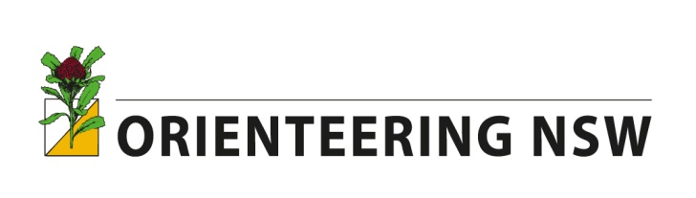
SYDNEY SUMMER SERIES
2nd annual Anniversary cup
Wed 1 February, 2017

Last year's Anniversary Cup at Boronia Park was such a success (with the lead changing many times during the race) we have decided once again to kick it "old school" and have the 2nd annual Anniversary Cup.

The location is Willoughby Leisure Centre, Small St, Willoughby, and the two course options are:

- A 30-checkpoint score event run exactly the same as the normal, weekly Sydney Summer Series rounds (start any time from 4.30-6.45pm).

OR

- A 7km line course with a mass start at 6pm. This will be the Anniversary Cup event. Trophies will be presented to the fastest female and male in this category.

Pre-entry for the Anniversary Cup line course is through Eventor. There will be some enter on day maps available. Results from both courses will be included in the usual SSS point score tables.

A free MINI kids course will be on offer as well- all away from car traffic.

The Sydney Summer Series showcases the best parks, reserves, bush tracks and harbour foreshores in a 45-minute navigational challenge that anyone can do. Participants range in age from 10-80.
