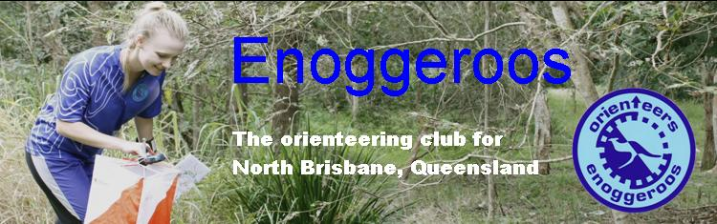

Sheepstation Creek OY 1

Location Wivenhoe Map Sheepstation Creek - 1:10000 colour
Event type OY – Middle distance format

Terrain Bush – Spur gully some rock features.

Date Sunday 5 March 2017

Starts Between 9:00am – 10:30am Close 12:00 noon

Organiser Jack Neumann

Setter Jack Neumann

Controller Rob Rapkins

Contact person Rob Rapkins Contact number 3256 6580

COURSE | SUGGESTED AGE CLASS | WINNING TIME | LENGTH | CLIMB
Hard 1 | M21 | 35 min | 6.4 km | 165m
Hard 2 | M17-20; M35; W 21 | 35 min | 5.6 km | 155m
Hard 3 | M16; M45; W17-20; W35 | 30 min | 4.5 km | 125m
Hard 4 | M55; W16; W45 | 30 min | 3.7 km | 110m
Hard 5 | M65+; W55+ | 27 min | 2.7 km | 70m
Moderate 1 | M14 | 25 min | 3.3 km | 110m
Moderate 2 | W14 | 20 min | 2.6 km | 95m
Easy | M/W12 | 20 min | 1.8 km | 60m
Very Easy | M/W10; M/W10N (shadowed) | 15 min | 1.5 km | 50m

Courses have been set to achieve the above winning times.
“Suggested Age Classes” are a guide only and not official. You may enter any course.
Terrain: Fast Gully/Spur and some patches of rock but offering challenges in navigation with gentle gullies and broken watercourses including small depressions, ponds and termite mounds.

Directions: Travelling from Brisbane, cross Wivenhoe Dam and continue on for approximately 2.9 k. From Esk travel approximately 28 k and look for O signs.
GPS coordinates -27.383104; 152.564322.

Parking: Please angle park as directed. There is a short walk ( up to 200m) to the assembly area.

Registration: As this is a pre –entry event there is no need to go to the registration table,
unless you have outstanding payment owing or to collect a hired SI stick.

Maps: Maps are printed on 100gsm bond paper. Plastic covers will be available at the start.

Start: Located near the assembly area. There is no water at the start.
Clear and Check your SI stick.
Collect your control descriptions for your course and stand behind the map tray with your course marked on it. Wait for the starter to start you.
Insert your SI stick in the unit at the pre-start and then follow the streamers to the start triangle which will be marked on your map. You MUST go to the start triangle. There will be a control flag there but no punch.

Download tent: After punching the finish control follow the tapes to the download tent.
You must proceed to the download tent even if you abandon your course. There will be water near the download tent.

Results: You will receive a splits printout with a detachable result tab.
Could you please assist by inserting your result tab in the plastic holders provided and then attaching your result to the results hanger.

Safety:
Access to Parking and assembly area is from the Brisbane Valley Highway.
This is a busy road. Please TAKE CARE when entering and exiting the Highway.
Early warning turn signage will be in place from both directions.

The gate will be open from 8:30am until 10am to allow easy access and to prevent a queue
forming at the gate. After this time you may enter but please SHUT the gate behind you.

Facilities:

Toilets: There will be NO toilets at the assembly area. The nearest toilets are 2.9 kilometres away at the 'day use area'. Please ask at registration for directions if needed.

Water: This will be available on the courses at designated control sites and also there will be some in the assembly area. To help the organiser it would help if you brought some for your personal use before and after your run.

Drinks Ice cold Soft drinks are available for sale near the Results.

