Marrinup (Dwellingup) MTBO - long distance champs
Sunday July 23 (morning)
Location: Marrinup townsite, 5km NW of Dwellingup

Setter: Duncan Sullivan 0418907613
Organiser: Anna Napier
Organising club: LOST
Courses: Age categories apply (see below) + EOD courses 2, 4 & 5
Registration: 9-10:30am***pre-entry required for championship classes*** (see Eventor)
Starts: 9am -11am (EOD entries start after pre-registered riders)
Courses close: 1pm

Note New distances for courses 4 & 5
Course | Class | Distance | Climb | Controls
1 | M21 | 36.0 km | 495m | 21
2 | W21  M17-20, M40, M50 | 29.2 km | 400m | 14
3 | W17-20, W40, W50  M16, M60 | 25.0 km | 335m | 14
4 | W16, W60,  M14, M70, | 17.0 km | 155m | 14
5 | W12, W14, W70, W80 M12, M80 | 13.4 km | 110m | 11

Facilities: Toilets, fire pits, tables. Free camping. No water.
Bring: SportIdent e-tag, compass, bike, helmet, water, food.
Phone reception is reasonable over most of the map
Shops, Cafe and pub in Dwellingup, plus limited bike spares at IGA and Dwellingup Adventures

Directions:
From Dwellingup: From the main intersection (Pinjarra Williams Rd and Newton St) travel NW then N on Newton St (which becomes Del Park Rd) for 1.3km, turn left in to Bandicoot Rd (gravel). After 1.1km take the right fork. After a further 700m take the left fork and drive west for another 1.6km to the camping area. Park where you can, having regard to the campers.
From Perth: Go to North Dandalup on SW highway and turn left at the roadhouse in to Del Park Rd. As you approach Dwellingup in the 80kph zone, turn right in to Bandicoot Rd and proceed as above.

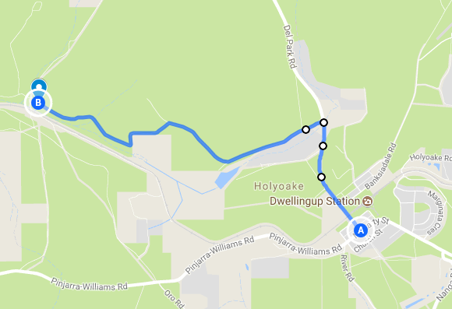

Entry fees | Full member | Casual member
Junior (<21)/Concession | $5 | $10
Adult | $15 | $25
Family maximum | $35 | $60
SI tag hire | $5 | Included

Marrinup was a mill settlement that burnt down in the 1961 fire. The townsite is now a free camping area. The map incudes the Marrinup MTB circuit, part of the Munda Biddi trail, the old golf course, a former POW camp, and a tourist rail line. Part of the map was first used for the Australian Middle distance champs in 2016. It offers a variety of trail types, and the western section has some challenging climbs for courses 1-3. Start times are a bit earlier than normal to reduce the chance of conflict with the train which will pass through the event area about 10.40am

Map: Marrinup 1:15 000, by Duncan Sullivan 2016-July 2017
5m contours. A3 courses 1-3, A4 courses 4,5 Waterproof paper (for championship classes only)
Mapped to IOF MTBO standard, except for the additional overgrown/indistinct track symbol of a mid-green overlay over the appropriate track symbol.

Terrain: Jarrah/Marri forrest with areas of rehabilitated bauxite mine with mixed native plantings, often quite dense. Relatively flat in the east, with steeper areas in the west (courses 1-3). Mix of fast gravel roads and tracks, tending to medium and slow rocky or rutted tracks in steeper terrain; well used MTB single track circuit with some sections of rocks or roots, and some technical trail features, usually with ‘B-lines’; old golf course fairways, generally medium riding speed; some less distinct tracks left by drilling rigs, generally slow riding due to rough surface, leaf litter, and revegetation, mapped as overgrown where they are quite indistinct (these are best avoided, but are mapped to aid navigation). Courses 1-3 will have some challenging climbs. Course 5 is designed to be possible to ride 95% of the course on good wide tracks and fairways.

Hazards: There may be occasional vehicles, pedestrians, horses, and mountain bike riders. The main single-track loop is usually ridden clockwise but it is not signed as mandatory to do so, and it is not marked as one way for competitors. You may encounter other riders coming from the opposite direction. You should stay left, with the oncoming rider on your right. Wildlife may include kangaroos and pigs. Loose pea-gravel can make cornering hazardous. Other dangers include fallen twigs and branches, roots, rocks, ruts and man-made trail features on the single track.
Road options: All courses have some route choice options on the main road to Dwellingup from Pinjarra. The road has recently been widened, there are wide gravel verges to use if you would rather not mix with traffic, otherwise there is a good breakdown lane on the bitumen for most of the road section in question. Obey all road rules and ride sensibly if taking these options. Other less safe sections of the main roads on the east and south of the map are marked as forbidden routes.

Train: Listen and look out for the train during the event and when leaving the site. You will need to cross the train line on a gravel road to get to the start. All courses also need to cross the track after the first few controls. There is only one steam train service during the event, travelling west leaving Dwellingup at 10.30 and returning about 12.30. A second service runs in the afternoon at 2.30. You may only cross the train line where mapped tracks are marked, or at optional crossing points marked with purple curved lines as below, and in terrain with orange tapes. Crossing points are likely to require dismount.
Optional Crossing points
This symbol is also used where two tracks almost meet and a short, marked route has been created to allow competitor access between them. Marked in terrain with orange tapes. Speed varies from medium to difficult.
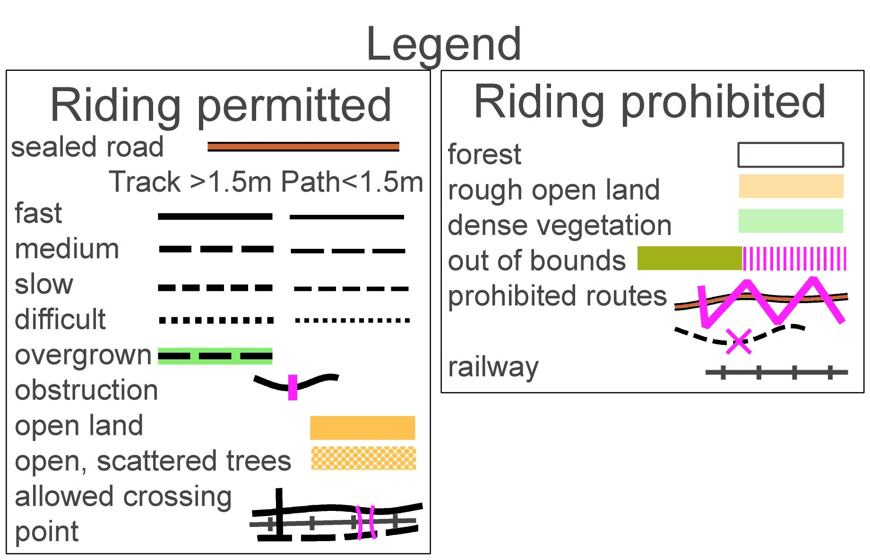
Start: approx. 300 m from assembly area. Warm up on the track on the south side of the rail line, 300m east or west of the power line only.
From 0900. Start interval 2 minutes
Start procedure: Arrive at the start at least 6 minutes before your start time. Clear and Check your SI unit prior to entering the start.
-3 minutes: Name check, SI clear and check.
-2 minutes: Move forward to map table. Each course map will be upside down in a tray with the course number on the tray. Ensure that you line up next to the correct map tray. Final instructions (if any).
-1 minutes: Pick up your map, fix to map board and prepare to start. It is the athlete’s responsibility to collect the correct map.
0 minutes: Start from stationary position, one foot on ground. After the start follow the track uphill (mandatory route) 100m to start triangle, marked in the terrain with a flag (no punch). If you need time to plan your route to the first control, move away from the start tent to the start flag to do this. Do not ride back through start area on course.

Sport Ident Sport Ident will be used for timing. Hire units are available at registration. You can attach the unit to your bike or hand/body. Make sure you have a safety line on the unit to prevent loss. If you lose your hire unit you will be liable for the replacement cost. Enter on day competitors must punch the start unit to ensure that your course is timed. When you punch the SI control, ensure that the unit lights up or beeps. On completion of event punch the finish unit, then proceed to registration tent to have your SI unit read and your result recorded. Hire units must be returned at the end of the event.

