SUGARBAG ROAD REVISITED
Qld State Series Event No 9
Sunshine Coast Council Recreation Area/
Ben Bennett Park/Caloundra State High School
Sunday 8:30 am, 24th September 2017
Thank you all for your entry into the Qld State Series Event No 9

Road Directions GOOGLE MAP LINK
From Brisbane: Allow 85 minutes from Brisbane CBD to assembly area. Travel north on the Bruce Highway. Take exit 188 – Landsborough/Caloundra, bear left onto Caloundra Road and back over the Bruce Highway overpass. Follow the Caloundra Road for 6.1km and turn left into Sugarbag Road. Follow Orienteering Signs for 1.6 km to assembly area. Take care turning right into assembly area.
From the North: Follow the Bruce Highway. Take exit 188A - Caloundra Rd / Caloundra. Follow the Caloundra Road for 6.1km and turn left into Sugarbag Road. Follow Orienteering Signs for 1.6 km to assembly area. Take care turning right into assembly area.
Park as directed, please park as economically as you can!
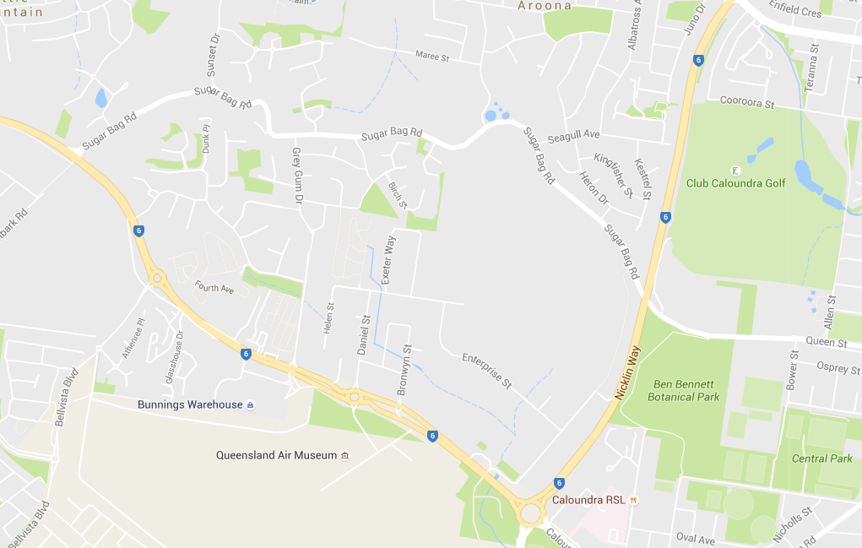
Start
Assembly Area
Assembly Area

Courses:
Course | Approx Distance | Approx Climb | Classes
1 | 13.3 km | 290 m | Men Open, Women Open Long, Social Long
2 | 11.5 km | 250 m | Women Open, Men 40 - 49
3 | 10.0 km | 220 m | Men 50-59, Women 40-49, Men 17-20, Social Medium
4 | 8.5 km | 190 m | Men 60+, Women 50-59, Women 17-20
5 | 5.5 km | 100 m | Women 60+, Men 14-16, Women 14-16, Social Short
Score 90 min | 15 km | 300 | Open to all with a briefing at 09:10 am and mass start at 09:15 am near the assembly area.
There are a lot of controls in close proximity to one another. Please be careful to ensure you punch the correct control by checking the number! Always be aware of riders coming in the opposite direction.

Registration:

Registration will open at 8:00am. Please make sure that all outstanding monies have been paid prior to the event. ALL competitors are required to go to registration. Your entry details will be confirmed and you will be issued with an SI stick (if hired); 2 cable ties and a reserve punch card. If you own an SI stick bring it to registration so that the number can be checked. For newcomers, basic instruction will also be available if needed, just ask the officials. Compasses will be available for loan and if you have requested a hire map board these will also be available at registration.

Map
Map size is A3 for all courses. Scale 1:5,000 for all courses, contour interval 5 metres. The 90 minute Score event will comprise a double sided map. The Start is on Map A and riders can switch to Map B once they have collected all controls on Map A or after 45 mins, whichever comes first. The Finish is only marked on Map B.
Legend will be on map.

MAP SYMBOLS
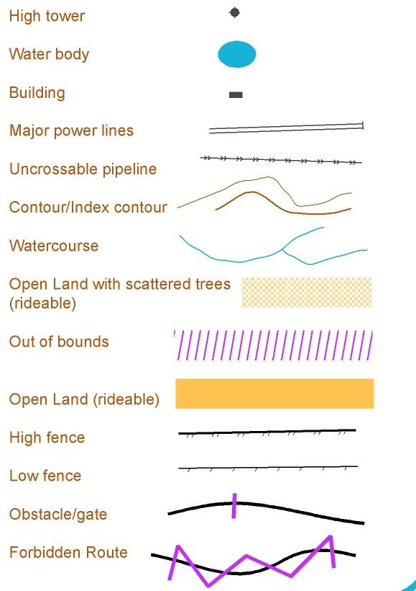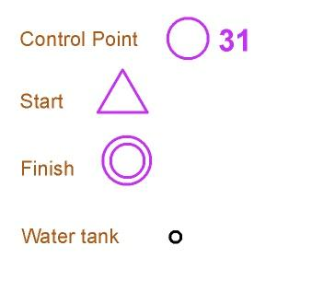

Notes for Riders:
Sugar Bag Road, Queen Street and Bower Street are OUT OF BOUNDS and not to be used by any riders. Some other paths and areas are marked as out of bounds on the map. Do not enter these paths and areas. Failure to comply with this requirement may mean we will not be allowed to use this area for MTBO again.

All of the riding areas in Ben Bennett Park/Sugarbag Trails are open to the public and riders need to take care, particularly of pedestrians and children in the eastern area of the map, and of other cyclists in the western parts. There will be riders in the Sugarbag trails area riding at high speed and potentially well above the ground. Be aware, particularly at junctions. Riders on all courses may need to cross a minor dead-end road and are asked to take care when doing so.

The Map:

The map has been significantly updated since it was last used for MTBO and a section of the Caloundra State High School grounds added. Tracks that were on the old map but not on the ground have been removed and tracks that were on the ground but not on the old map added. In addition more contour detail has been added to make the map align more with the ground. However, a map of an area as intricate as this can only ever be a representation and it is a long way short of perfect. Please note:

- The single track network is intricate with most of the tracks being single direction. These have been marked on the map with arrows. Riders must obey these direction arrows. A lot more arrows have been added to the map such that every junction with a one-way track has an arrow on the map where the track enters the junction.
- There are numerous wooden obstacles on the area. Where these are likely to be obvious to the MTBO rider they have been marked with “Notable Object” symbol which is a heavy black cross. It is highly recommended that you do not attempt to ride any of these obstacles
- Small areas marked as “clearings” show places where the tracks are close together and riders are permitted to cross from one track to another. These have been added to assist the route planning and navigational complexity of the courses. In most cases there is some evidence of riders going from one track to another. Competitors may walk their bikes from one track to another in these areas. You may not go off the track in places where there is no marked “clearing” on the map. In some places bunting has been added to designate definite no crossing points.
- Many of the loops have lots of twists and turns that simply cannot be represented at the 1:5,000 scale. Thus, generally, the meandering tracks will take longer than you think.
- Between each visit to the area there were minor tracks added and minor tracks removed on the ground. You should expect this to have continued between the final map update and the event
- In many places there are "A" and "B" routes, with the "A" route more difficult. Where the “A” route is long enough to show up on the map and likely to be obvious to the MTBO rider it has been shown.
- There remains a lot of contour detail (eg lumps, bumps, gullies and watercourses) that are not shown on the map
- There have been a number of bridges installed in the recent past and that was continuing as the map was being finalised. They are not shown on the map. These are typical MTB bridges being; narrow, without rails and with significant drops either side. Only attempt to ride these bridges if you are confident and competent in doing so.
- There are some quite technical and sandy tracks on the area. Only attempt to ride these tracks if you are confident and competent in doing so.

Course Notes:

- The nature of this area lends itself to cheating, in particular going the wrong way on a one-way track and crossing between tracks in places not marked as “clearings”. We want the event to be fair for everyone and must rely on your honesty. If you see someone doing the wrong thing, assume they doing it accidentally and tell them. If they then choose to continue to do the wrong thing you are strongly encouraged to advise the event officials
- Note that if you miss a turn off a one-way track and have gone past by less than 10 metres you may dismount and walk your bike back to the junction. Otherwise ride on and return via a permitted route

Start:

For Courses 1 – 5 allow a 15 minute easy ride to the start. Follow the bike path beside Sugarbag Road to the east. Cross over the Nicklin Way and continue following the bike path along Queens Street past the Ben Bennett Park carpark and Caloundra State High School. Turn right into Bower Street immediately past the High School and follow Bower Street to the Start. There are toilets located adjacent to the Ben Bennett Park carpark.

The start for the 90 minute score will be near the Assembly Area with a briefing at 09:10 for a mass start at 09:15 am.

Note that the bike path between the Assembly Area and the Ben Bennett Park carpark is on the course and you may encounter MTBO riders travelling at race speed. Be particularly careful on the bridge over the Nicklin Way which is quite narrow.

Clear & Check:

You will be directed through a clear & check area before you reach the start. It is the competitor’s responsibility to ensure they have correct SI stick and that it is cleared before they start.

Start –State Series Event No 9:
In this event, competitors will not have a pre-allocated start time. Two minutes before the start time, you will be able move into the start lanes. At 1 minute, you can collect the map for your course and fix it to your map board etc. You can also check out the course while doing this. At end of the series of beeps, you must move forward immediately. There is a “START” control to punch. You must move away from the start area immediately as there will be riders behind you wanting to start.
Please note that you cannot ride back through the START and pre-start area after you have started. If you attempt to do so you will be disqualified.
Finish:
At the finish, punch the “FINISH” control and make your way to the finish tent to have your SI stick downloaded. If you have a hired SI stick, we will retrieve this from your bike. Results will be posted to results hangers as soon as possible after the event. Posted results will be preliminary, until all competitors are in and any protests are resolved. If you decide not to finish your course, you must report to the finish tent when you return to the assembly area to avoid a search being mounted for you!
Safety:
If you encounter an injured rider, you MUST abandon your course and render whatever assistance you can. Send another rider back to registration for assistance, if possible. You will be permitted to either restart from your last control preceding your abandonment or be credited with organiser Qld Champs and State Series points at your preference. Mobile phone coverage is available on course and assembly area. Bring your own medical items for pre-race treatments. A first-aid kit will be available in the assembly area for emergencies. There will be a trained first-aider in the assembly area.

Safety Bearing:
Sugarbag Road/Queen Street are located on the northern side of the map and follow this to the west to the assembly area.
Out of Bounds Areas:
Sugarbag Road and Queen Street runs across the northern side of the map and Bower Street runs down the eastern side of the map and are "OUT OF BOUNDS".
Course Closure:
Courses closes at 12.00pm.
If you have not finished your course at this time, you must abandon your course and return to the assembly area as quickly as possible AND REPORT TO THE FINISH TENT. The SPORTident units are programmed to turn off at set times so you will be unable to punch controls if out after the closure time.
Water:
Everyone is urged to drink plenty of water before starting their ride. There is no water out on the course, so you must take all water you require for the event with you. Please bring your own water for use before and after the event. No water will be available in the assembly area.
Complaints and Protests:
Complaints must be lodged within 15 minutes of the last finisher in any class. Complaints must be made in the first instance verbally with the Event Organiser via the Registration Desk. The Organiser will assess the complaint and make a ruling. If the complainant is still dissatisfied, they may lodge a formal written protest with the Registration Desk. The Event Organiser will then appoint a three person jury to assess the complaint. The Event Organiser will chair the jury meeting but will not vote on the outcome. The decision of the jury will be final.

Catering:

Portable toilet and cool drinks for sale will be available at the registration / parking area.
Control Collection:
Many hands make light work. The organisers for this event would very much appreciate it if competitors could provide some assistance after the event collecting controls. If everyone assists by collecting the controls from within one small “region” of the map we will have them all in very quickly. Please don’t be shy in volunteering for this activity!

Anything Else you Want to Know:
Then contact Geoff Moore email: capqld@powerup.com.au ph:0411 231 006.

