Ultra-sprint is a fast and fun format where the idea is to read your map carefully. On the course will be many controls very closely spaced and participants need to read the map to determine which control is on his or her course. There is a catch – there are no control descriptions and no control numbers! Instead the control circle will have a focus point or centre dot to help runners locate the correct control.

Participants will need to complete three courses with the cumulative time added together for a total. If a runner punches an incorrect control and realises, this can be corrected by then punching the correct control with no penalty. However, if a runner punches an incorrect control or misses one entirely and does not correct, rather than recording a mispunch, the runner will instead receive a 30 second time penalty per missing or incorrect control.

For this event, each person needs to complete three courses in any order:
- Short: 3 x 0.7km – 1.0km
- Long: 3 x 1.2km – 1.5km
There will be a separate start for each course with 30 seconds between starts to speed up queues.

Below is an example of how controls may be distributed.

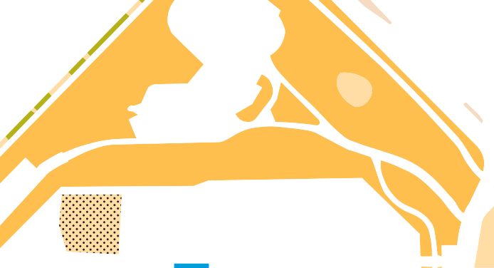

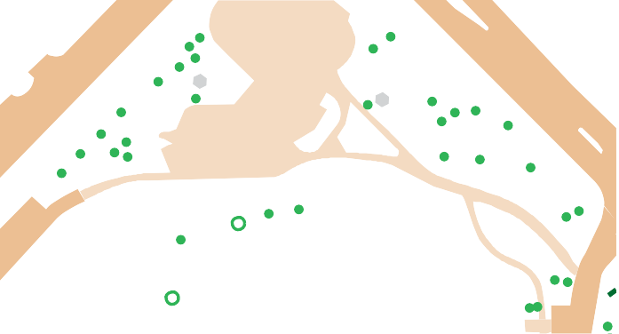

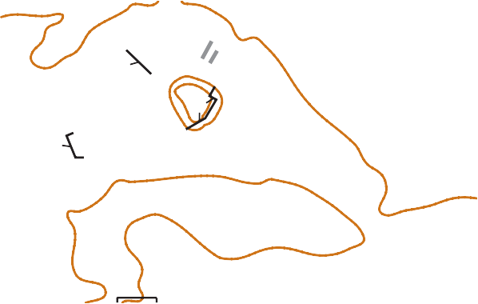

178
176
173
180
179
181
177
171
172
174
182
175
183

The following special symbols will also be used:

Staked or very small tree
Prominent tree
Large tree
Prominent pole or rubbish bin
Artwork, monument or water fountain
Other prominent man made feature
Garden bed or private property – please do not enter or cross

Seats have not been mapped.

