Sprint The Hills

General info:
Come to Adelaide Hills and run 3 different sprint courses in one day. All trainings will be with SportIdent.
Trainings set by Manu Jurado (Coach and mapper in residence)
Date:
Sunday 10th December
Location:
Blackwood Forest and Heathfield High School
Coordinates Google Maps
Blackwood Forest (Start / Finish)
https://www.google.es/maps/@-35.0291947,138.6259909,114m/data=!3m1!1e3
Heathfield Oval (Start / Finish)
https://www.google.es/maps/@-35.0230041,138.7143973,121m/data=!3m1!1e3
Program:
10.00 am: Sprint Intervals Blackwood Forest
1.00 am: Sprint Qualification Heathfield High School
2.00 pm: Sprint Final (Chasing start) Heathfield High School
Technical information:
Blackwood Forest (new map Nov 2017) ISSOM 2007 1:5.000 / 2.5m
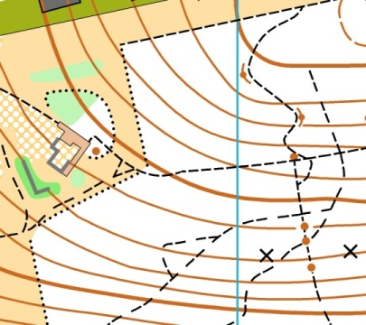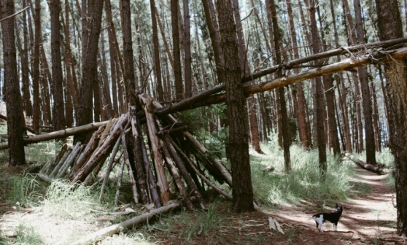
Heathfield High School (new map Nov 2017) ISSOM 2007 1:3.000 / 2.5m
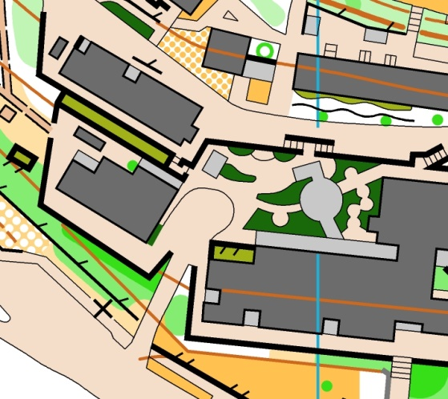
Entries:
Juniors (18 and under): $5
Adults: $10
Please confirm attendance before Thursday 7th December to Manu Jurado (atoja92@gmail.com)

