Adelaide HS – Mapping workshop

General info:
The mapping workshop is focused for young and adult mappers who have a little bit of experience with mapping. The idea of the workshop is to map a small area (1-2 hectares) in Tampawardli Park (West Parklands) with a lot of vegetation detail, which is a very subjective issue on orienteering mapping. Then we will digitalize our field work at home and on 7th February (Wednesday) we will train on the different maps we made (by different mappers) from the same area. Then we will discuss our mistakes and improvements of our “bush-art” maps.
The aim of the following example the same area mapped by different Swedish mappers:
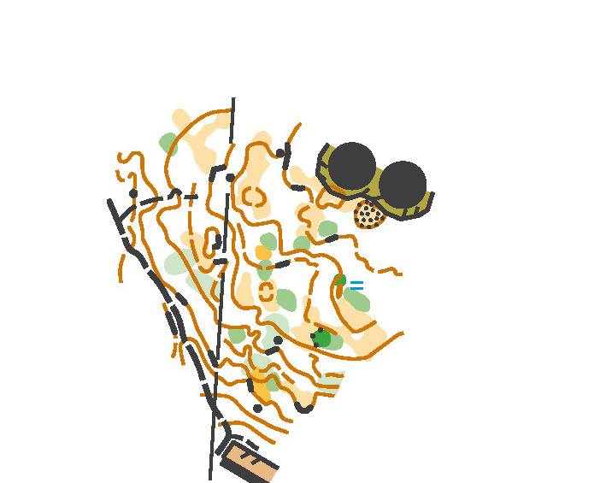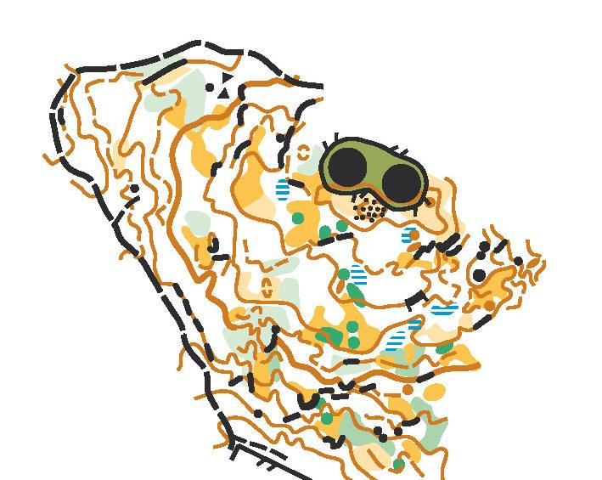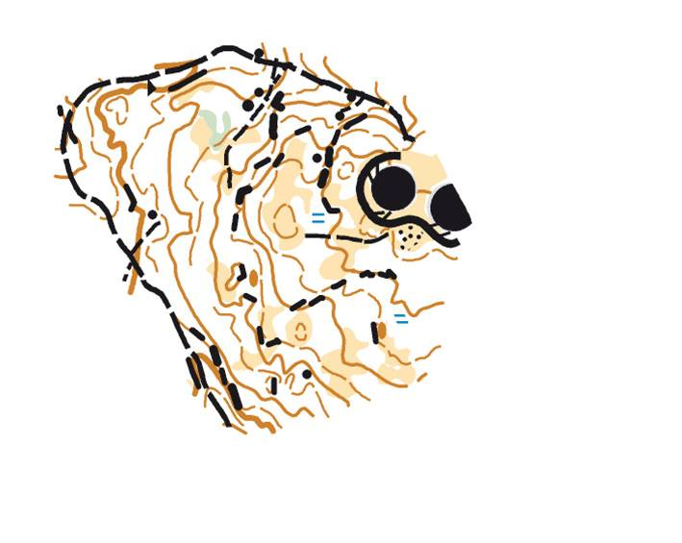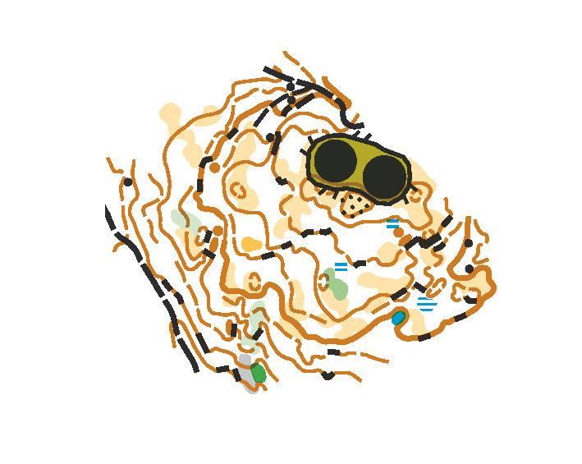
Material:
-Field work material (colour pencils/pens, mapping board, compass)
-Tablet / Smartphone (if you are mapping with OOM-Ocad), external battery
-Hat, water, sunscreen
For those who are coming I (Manu) will send you two days before via Dropbox the georeferenced base map (aerial image and contours). For those who are mapping with paper&pencil, please print out the field work base map at home (field work should be printed out in 1:2.000 if the final map is in 1:4.000). I will point out the area to be mapped with a purple outline.

Date:
Sunday 4th Feb (changed from Sat 27th Jan)
Location:
Adelaide High School – Tampawardli Park

Coordinates Google Maps (Car park):
https://www.google.es/maps/@-34.9267439,138.5855971,18.25z
Burke Oval Car Park
Program:
9.00 am: Start field work
11.00 am: End of field work
11.30 am: Mini Sprint training (previous area mapped by Manu Jurado)
Entries:
Free entry fee
Please confirm attendance before Friday 26th January to Manu Jurado (atoja92@gmail.com, phone 0487631801)

