South Parklands – Australia Day

General info:
On Friday 26th January, the Australia Day, OSA will organize a special training for those orienteers that are coming. Come and try a multi technique training in Veale Gardens and Wattle Park, South Parklands. Starts from 9 to 10 am. Training will be with SportIdent.
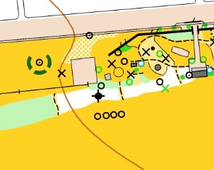
Date:
Friday 26th January
Location:

Coordinates Google Maps (Car park): -34.937052, 138.599759
Adelaide Pavilion car park (off South Tc – just west of the intersection with King William St)
https://www.google.es/maps/place/34%C2%B056'13.4%22S+138%C2%B035'59.1%22E/@-34.937052,138.5987912,286m/data=!3m2!1e3!4b1!4m6!3m5!1s0x0:0x0!7e2!8m2!3d-34.9370519!4d138.5997594

Program:
9.00 am: First start multi technique training
10.00 am: Last start multi technique training
Entries:
$2
Please confirm attendance before Wednesday 24th January to Manu Jurado (atoja92@gmail.com, phone 0487631801)

