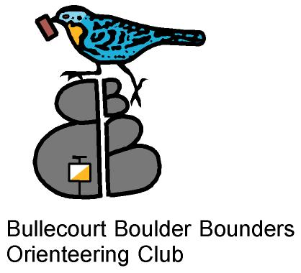 Orienteering-
What’s it like?
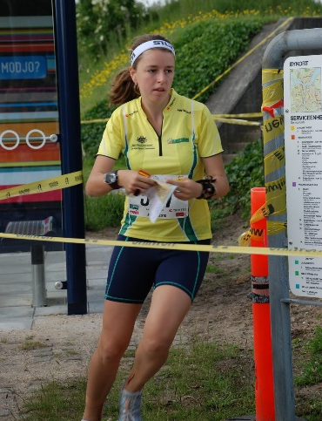
Where: Warwick West State School, George St.
When: Thursday, 8th February 2018.
Time: 5:00-6:00pm.
Bring: Water bottle, running shoes, $5 plus $1 per extra course.
Website:
www.oq.asn.au/event-calendar
Turn up between 5:00 and 6:00pm and try a Very Easy, Easy, Moderate or Hard course, or if you have time, do them all! Afterwards, if you and your parents can stay, we’ll have pizza (at no cost), you can buy a drink, and hear more about the sport. Enquiries: Phone Marion Burrill on 0487 572 553
Orienteering- The Thought Sport

