Sprint the Hills II – Sprint training

General info:
Come to the 2nd Edition of the Sprint the Hills and run 2 different sprints trainings in Adelaide Hills. The first one will be in Mt. Barker and the second one will be in Heathfield High School. Both trainings will be with SportIdent.
Trainings set by Manu Jurado (Coach and mapper in residence)
Date:
Sunday 11th February
Location:
Mt. Barker – Keith Stephenson Park
Coordinates Google Maps (Car park)
https://www.google.es/maps/@-35.0736638,138.8566522,273m/data=!3m1!1e3
Heathfield High School – Heathfield Oval
Coordinates Google Maps (Car park)
https://www.google.es/maps/@-35.0223422,138.7150455,156m/data=!3m1!1e3
Program:
8.30 am: Sprint Mt. Barker
11:00 AM approx: Sprint Heathfield High School
Technical information:
Mount Barker (Map made by Adrian Uppill and Stefano Raus in 2017) ) ISSOM 2007 1:5.000 / 2.5m
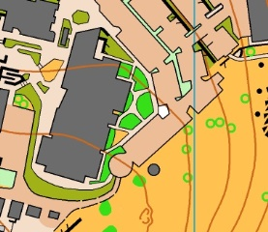
Heathfield High School (Map made by Manu Jurado in Nov 2017) ISSOM 2007 1:3.000 / 2.5m
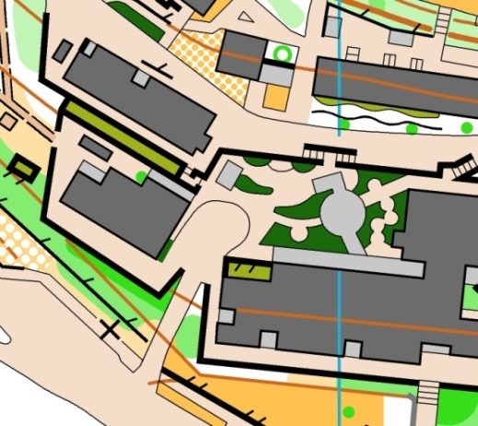
Entries:
Juniors (18 and under): $5
Adults: $10
Please confirm attendance before Thursday 8th February to Manu Jurado (atoja92@gmail.com)

