Come and Try Foot Orienteering in the Park

Where: Johnson Park- -Entrance off Mary River road, Cooroy
Location on Google Maps
When: Sunday 15th April
Time: Start times between 9:00 am and 10:30 am. Courses close at 12:00 midday.
What to bring: Hat, sunscreen, water, comfortable shoes and clothes and a compass if you have one. Also cash if you have not prepaid.
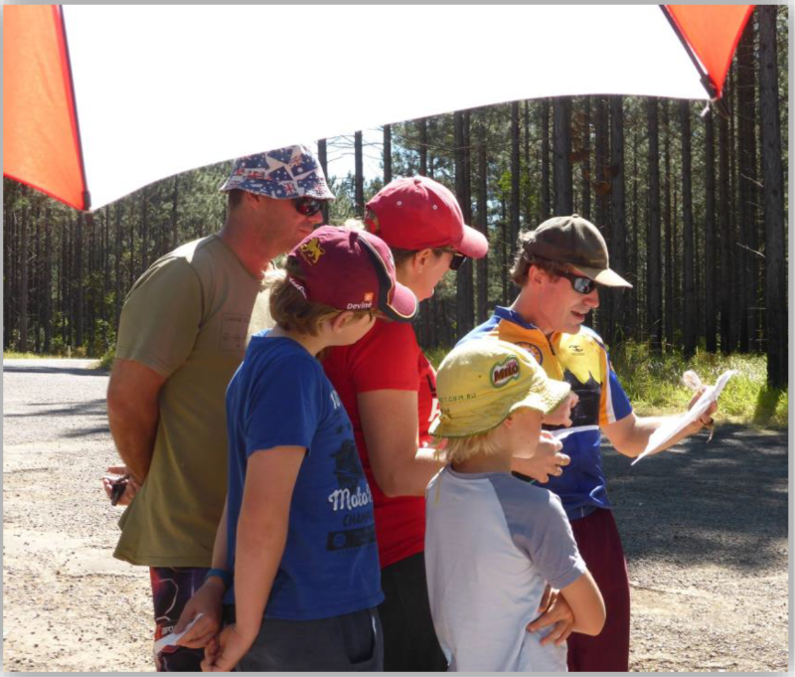
Entry: This event is part of the Orienteering Queensland calendar of events so entry and prepayment is available on the “Eventor” website – linked here.
The event website has links explaining how to register an “Eventor” log-in and information about available courses and entry fees.

Entry Cost is $5 each with a maximum family cost of $15 to cover map printing.

Alternatively, you can enter and order a map by emailing Sunshine Orienteers by Midnight Thursday 12-April.

Mail to: sunshineorienteering@gmail.com
Enquiries to the Organiser - Brendan Henry - 0403348792
Spare maps will be available for Novice entries on the day.

Experienced Orienteers will be available to guide new comers into orienteering

