Come and Try Foot Orienteering and MapRun in the Park

Where: Napier Road, Eumundi
Location on Google Maps
When: Sunday 12th August
Time: Start times between 9:00 am and 10:30 am. Courses close at 12:00 midday.
What to bring: Hat, sunscreen, water, comfortable shoes and clothes and a compass if you have one. Also cash if you have not prepaid.
Experienced Orienteers will be available to guide new comers into orienteering
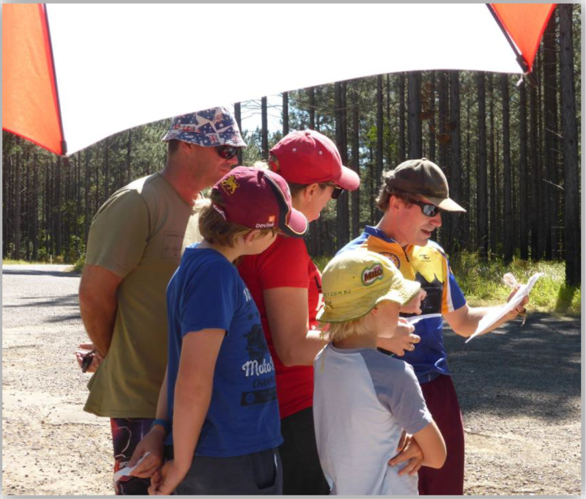
Entry: This event is part of the Orienteering Queensland calendar of events so entry and prepayment is available on the “Eventor” website – linked here.
The event website has links explaining how to register an “Eventor” log-in and information about available courses and entry fees.

Alternatively, you can enter and order a map by emailing Sunshine Orienteers by Midnight Thursday 9-Aug-18.
Mail to: sunshineorienteering@gmail.com

Courses available
Novice line course | Approx 1.5 km
Moderate line course | Approx 2.5 km
MapRun Score event | 40 minute duration

Entry Fees
$5 per person with a maximum of $15 for a family group (only make 3 entries in Eventor).

Mark Petrie – Event Organiser – Tel 0429 899 928

