Wahroonga Ultrasprints Results 15th July 2018
#M: number of controls missed @ 45 secs each
#E: number of extra controls @ 15 secs each
#O: number of out of sequence controls @ 45 secs each
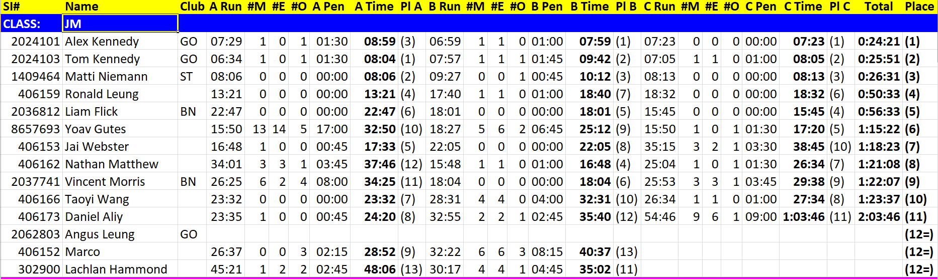
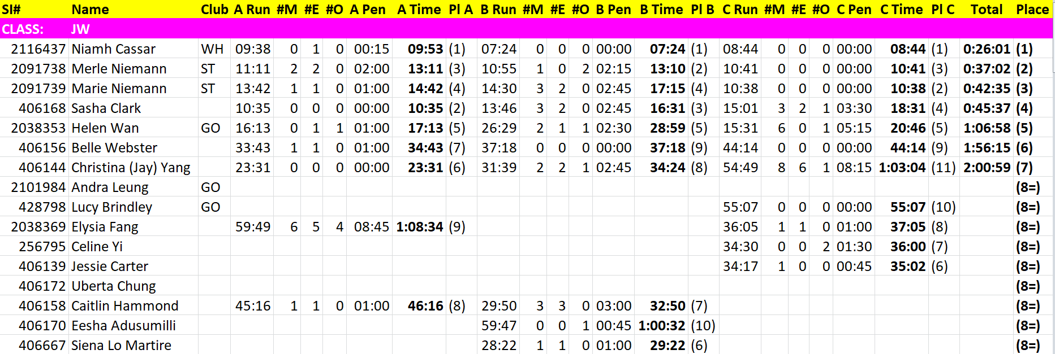
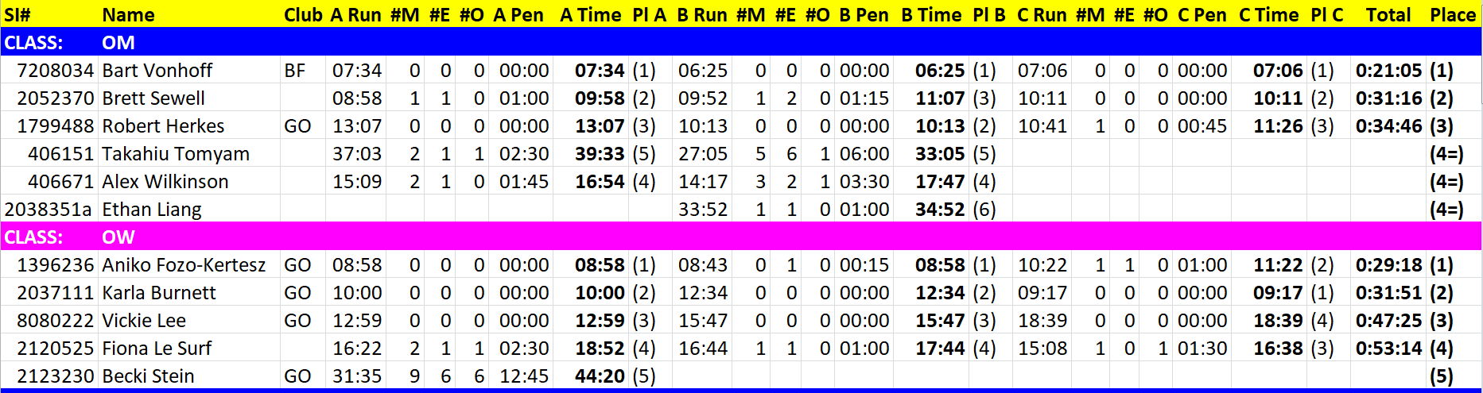

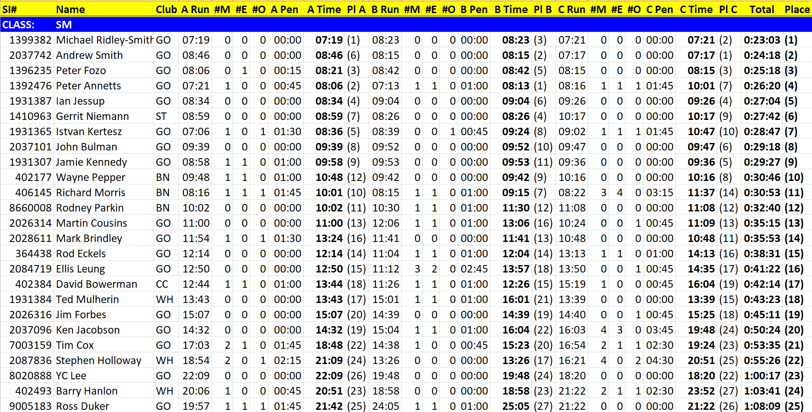
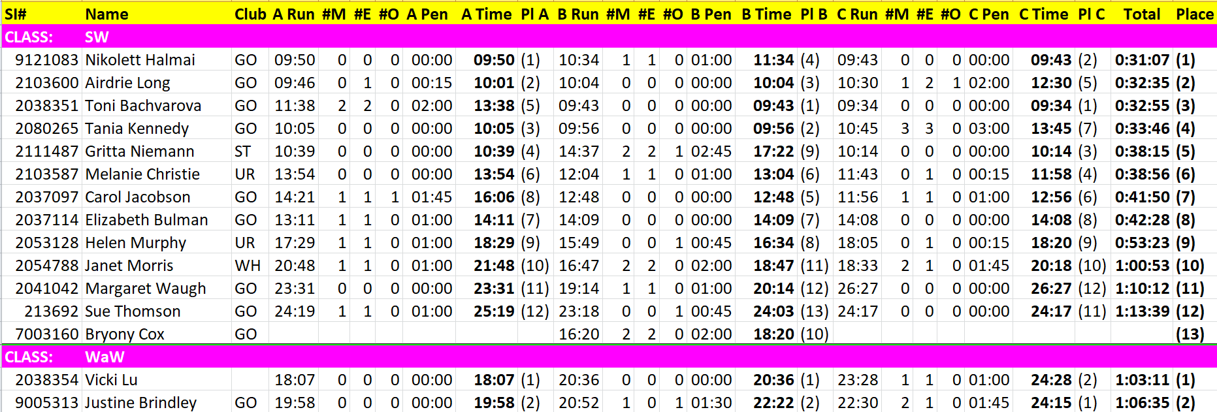

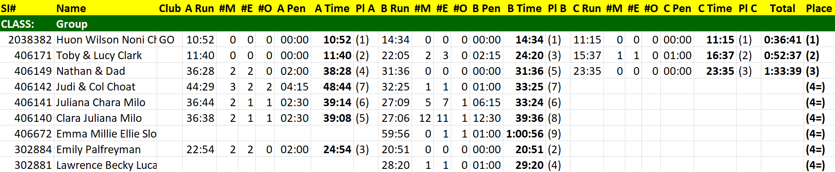
Actual Courses:
