**The 2018 Schools Invitational Team Camp, October 1-7.**

There's a special Camp at **West Beach Caravan Park** during the National Australian Orienteering Championships Carnival. **All juniors** aged 9 to18 (Years 5-12) who are **NOT** in the Schools State Teams, **and their families**, are invited!

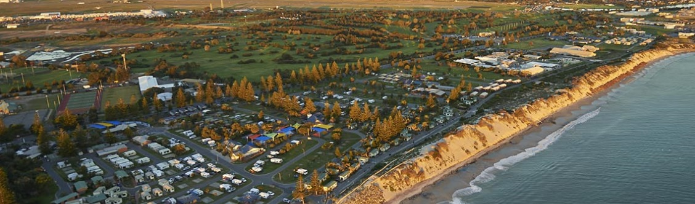

You don't have to be great at orienteering to attend, just keen. **Make new friends, learn new skills, and have fun together!** Learn new skills, make new friends and have lots of fun! It will be a school holiday to remember!

 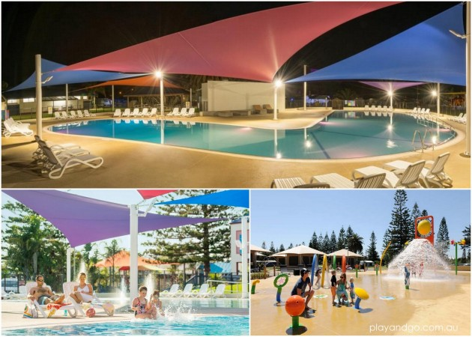

Because it is not part of the official Carnival program, and completely separate from the official Schools State Team Camp, parents will be required to stay at the Caravan Park to help and to supervise the children, and to provide transport to the daily Carnival events, where they will compete as members of the Invitational Team.

You can come just for a few hours, one day or stay for all 6 nights. All program details and entry information are on: eventor.orienteering.asn.au/Events/Show/6967

**Day visitors of all ages are most welcome.** Come drop in and see what it is all about! Come join the 40 juniors and 15 adults from all over Australia and NZ who have already signed up. There is a $5 Caravan Park facilities fee for everyone, which is payable on entry.

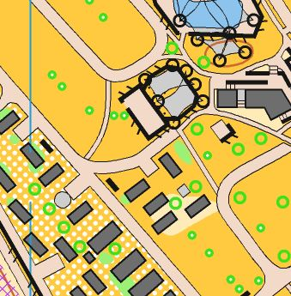

After a day at the Carnival, participants will have a chance to relax and play. There will be talks and social activities after dinner.

Most afternoons will be unstructured. Come for a **swim, play** or do the 2.5km **DIY course.** It is a 'permanent' course set up from Oct 2-6, and classes are <14, Open and >55.

There is also a gold coin donation for participating in organised Camp activities. If you wish to join us for dinner at 6pm, notice is required. Cost is $17 per person (Main +Dessert. Vegan, Vego and GF available).

**After dinner**, there will be a debrief (discuss how you went) and discussion of the next day's map and event, and a **short talk.** This will be followed by some group activities. Program (subject to change, see Eventor for latest) is as follows:

Mon Oct 1. Intro. **Techniques for Terrains**. Modify orienteering styles to suit sand, mining, granite, etc. (A Barnett). **Ice breaker.**

Tues Oct 2. **Injury avoidance.** (C Hogg). **Trivia Quiz.**

Wed Oct 3. **Technology to Train.** Using Strava, Garmin etc. to identify strengths and weaknesses. (A Barnett). **Kahoot.**

Thurs Oct 4. Informal night out at Glenelg. No catered dinner.

Fri Oct 5. Free day. Excursion prices are for advance group bookings only. Book now! Last minute bookings, if places are available, will incur a higher fee.

**SkyChallenge.**  Mega Adventure Park. 9am. $40

**Dolphin Cruise.** Port Adelaide. 1pm. Sprint historic precinct after. $7.

**Night-O Relays.** Bring headlight.

Sat Oct 6. **Dare to be the best.** But who to lean on in the long haul? (B Lawford). **Farewell Party.**

Most evening sessions will be held at the Sports SA meeting room, 500m away from the Hub dining room and Bunkhouse.

Photos from last year's Camp below:

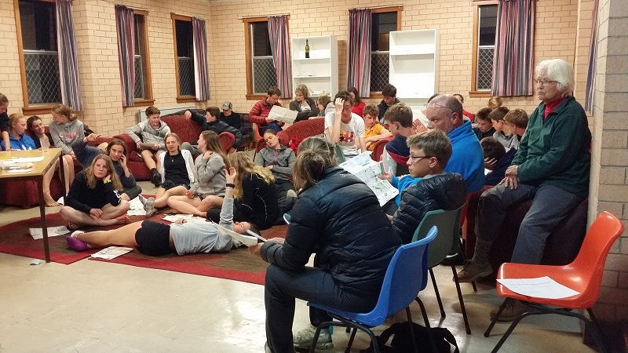 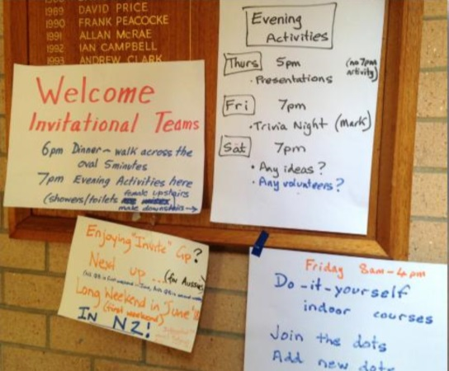

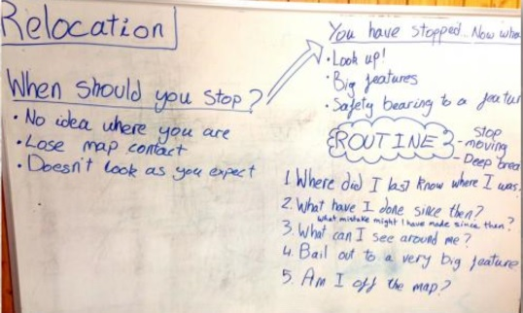 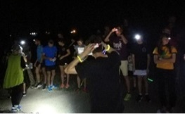 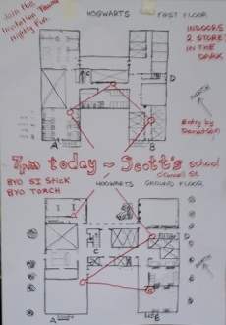

For more information, contact Aylwin Lim 0438 322 761 or ayllim@netscape.net