Hello SO members and friends,
Sunshine Orienteers Christmas breakup is this Sunday. (Free for members.)
Time: 9am for a 9:30am Start. Please don’t be late.

Date: Sunday, 16th December.
Event: 60min foot score event OR 60min MTBO Score event. It is digital* and it is social.
Place: The assembly / start / finish location will be near the Brightwater Dog Park with parking off Heliconia Street. Here is a google maps link
Sunshine Orienteers Xmas party location at Brightwater
Bring: a smartphone* , and a small plate of Christmassy food to share. For example: plate of fruit or cake/slice.
Wear: something Christmassy. If not something red, white or green. Or be an individual.
A hamburger or sausage sandwich and a drink will be provided for free if you are a member of SO or MTBO. If not there is a small charge of $5 per adult and kids free. Eating approx.: 11:15 am
*Smartphone. Instructions on how to download app before you come are on eventor.
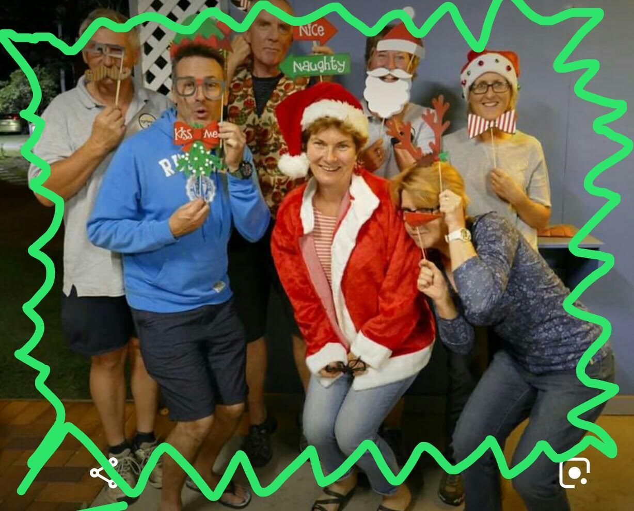
ENTER: To help SANTA you must enter through Eventor by midnight Thursday 13th December to guarantee a map and a burger.
Hope to see you there!
The Sunshine Orienteers Committee.
More info phone Deb
0439979261

