How to Enter a Single Stage/s

If you only want to enter one or two of the event stages, you can choose them under ‘Races’…
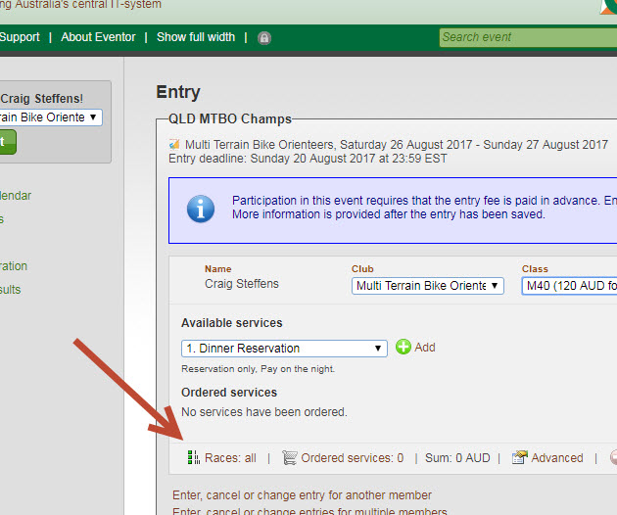
Select the ones you want…
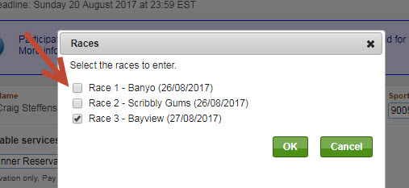
The price doesn’t change yet, but click on ‘Next’ at the bottom and it will make the entry fee adjustment on the following screen…
