Information Flyer Calophylla SOL 18th Aug 2019 Version 2: 24/07/2019
The Event
This is an SOL (State Orienteering League) Orienteer of the Year (OY) event, standard/classic distances. Runners may run any course, but to obtain OY points they need to run a course relevant to their age class or higher.

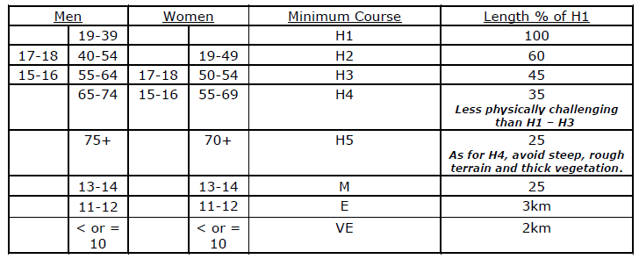
Note that course lengths may vary according to the terrain.

Terrain
Calophylla is typical granite outcrop country, the map area is a long ridge about 1.2 km north/south and 1.3 km east/west. The terrain slopes upward to a hill-top to the south with a rise of about 100m. Most courses do not go to the top!
There are two main creeks with many minor creeks, and extensive bare rock on the east side. The vegetation is mainly eucalypt bush with some tee-tree areas.
The area was burnt a few years ago and is now open where all courses go. The green areas shown on the maps do not reflect the current thickness of the bush. Much of the low-lying vegetation is now burnt sticks, with some low and sparse re-growth. No re-mapping of the vegetation has been done.
Remnant fences have essentially disappeared; there may be fence wire on the ground.

Courses
Eight courses have been planned in accordance with Standard Event State Orienteering League specification; H1 to H5, moderate, easy and very easy courses.

Starts
The pre-start point is the same for all courses, at the south west corner of the gravel pit. The sub-hard courses start off immediately in a westerly direction while the hard courses start off after a 10 metre run in a southerly direction.
NO WATER will be at the pre-start. Water will be available at the gravel pit and on the courses and at the finish.

Map Parts
Due to the restricted area the H1 and H2 courses are in two parts, printed on the front and back of one page. Follow the route from the start triangle to the last control on Part 1. At the last control on Part 1 turn over the map and the same control is shown as the start on Part 2. Part 2 covers the controls to the finish. Descriptions for the parts are printed on the relevant part.
Directions
From Perth to Yarra Rd is about 65 km. Allow about 90 mins to the assembly area. Take the Great Eastern Hwy to The Lakes/York turnoff, and turn east into the Great Southern Hwy.
At about 13 km turn south into Yarra Rd.
After 1.7 km turn left into West Talbot Rd (sometimes signed as Talbot West Rd).
After 7.8 km turn right into Ridley Rd (on the way West Talbot Rd crosses the Helena River and passes Pony Rd on the left).
After 4.5 km turn south into the gravel pit access track, allow extra time due to the condition of this road, as below.
Note 1: Ridley Rd is a gravel track with numerous potholes and some washaways. All can be navigated by smaller cars; please drive carefully.
Note 2: If it has been raining near the event date there may be big puddles on Ridley Rd. All can be driven around.

An alternative approach to the gravel pit access road is via Yarra Rd and Ridley Rd from the west, but includes more gravel driving, and Ridley Rd from this direction has much deeper puddles, if it has rained recently.

Parking
The assembly area is in the gravel pit about 250 m south of Ridley Rd. There is limited parking in the pit area itself and it is recommended that it be used by smaller vehicles.
There is a section of the pit which may contain water if there has been recent rain (it was mostly dry in mid-July eg), further restricting parking.
There is quite a bit of off-track parking along the gravel pit access road, it is recommended that 4WD and larger cars use these areas. Please park well off the track.
Finally if needed park off-track along Ridley Rd, or along the minor track to the west of the gravel pit access road, but only for about 250 metres (sub-hard courses use the more southern part).

