BURRA BUSH WEEKEND
Paradise & Mulga Valley
August, 17-18th.
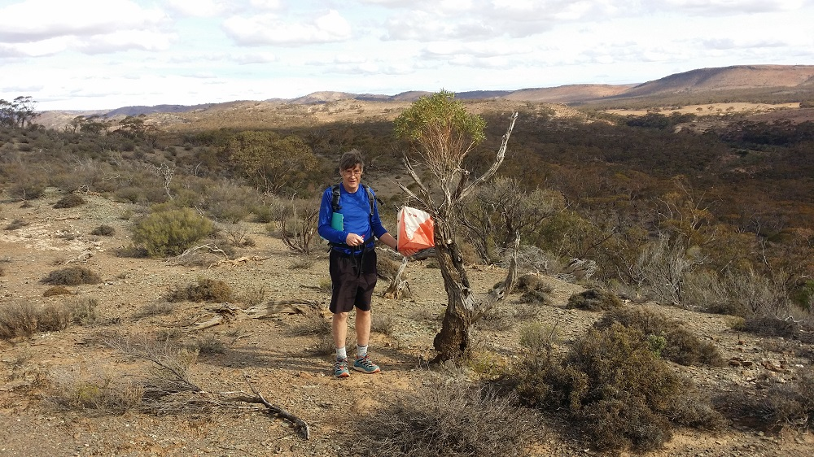
Beautiful country 3 hours North of Adelaide.
On-site bush camping, or stay at historic Burra.
Register and pay by Aug 14th for a discount.
Easy courses and limited Enter on the Day available.
