Hi all

Please don't forget to fill in the Participant Questionnaire on Eventor for Paradise event. https://eventor.orienteering.asn.au/Events/Show/7859 Survey closes in 4 days.

It only takes a few minutes. There is no event that is perfect, and no course that cannot be improved. All of you have made a lot of effort to get there and travelled a long way, and it is important that the organisers (in any event) provide you with the best possible experience. I would be really happy to hear your thoughts and suggestions.

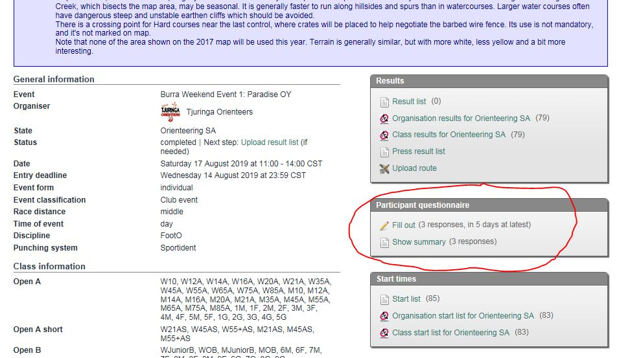

Three very good points have been raised so far:

1. Start window of 1.5 hours is too short for young families, who have to go out in turns.

- Yup!. Didn't even think of that. All bush events should have a minimum 2 hour start window.

2. Poor condition of access track could have caused problems, esp. for those with caravans or trailers.

- Yup! It should have been highlighted on Event info.
- We did have contingency plans involving 4WD shuttles, and even cancelling the event in case of extreme weather; and Des Norman did bring up 6 buckets of rubble and spent over an hour tidying up the track the day before event.

3. Courses 1 and 2 shared the same leg as C4 and 5, but in opposite direction, and this is not ideal.

- Agree. Given the low expected numbers for C1 and 2, I did not think this would be a big problem, but restricting myself to 36 controls for 9 courses was perhaps a bit too frugal. A few extra controls would have solved this problem.

Then compare leg times on Winsplits. http://obasen.orientering.se/winsplits/online/en/default.asp?page=classes&databaseId=64712 Legs where you lost time are highlighted in red.

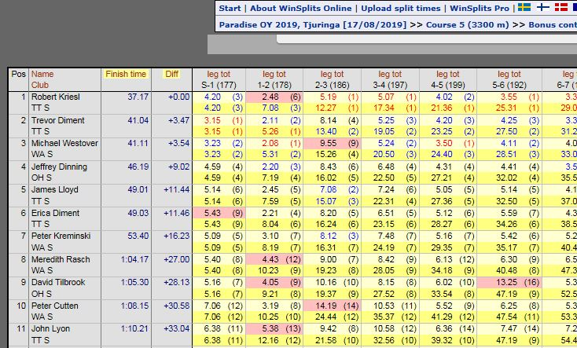

Please also check out Route Gadget. Even if you don't have GPS tracking, you can still draw your route from memory.

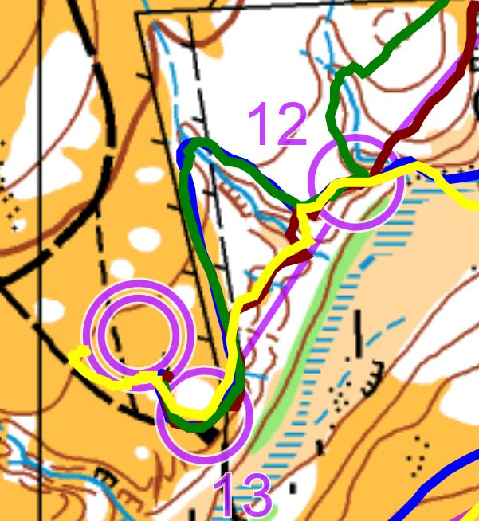 4 routes to last controls shown.

Thanks

Aylwin

