Bulletin 1

Welcome to Adelaide Sprint Camp 2020

Orienteering South Australia would like to send the best welcome to all participants of the Adelaide Sprint Camp

I would like to state, how much we’ll enjoy by showing you South Australian hospitality. We are taking the pride of organising the camp in unique areas in Stirling and Gawler which is 40 kilometres from Adelaide and has a history dating back to the 7th century BC. Adelaide’s industry is one of the strongest centres in Australia. I believe that the areas used are some of the best and most qualified in the State and will a perfect area for the event.

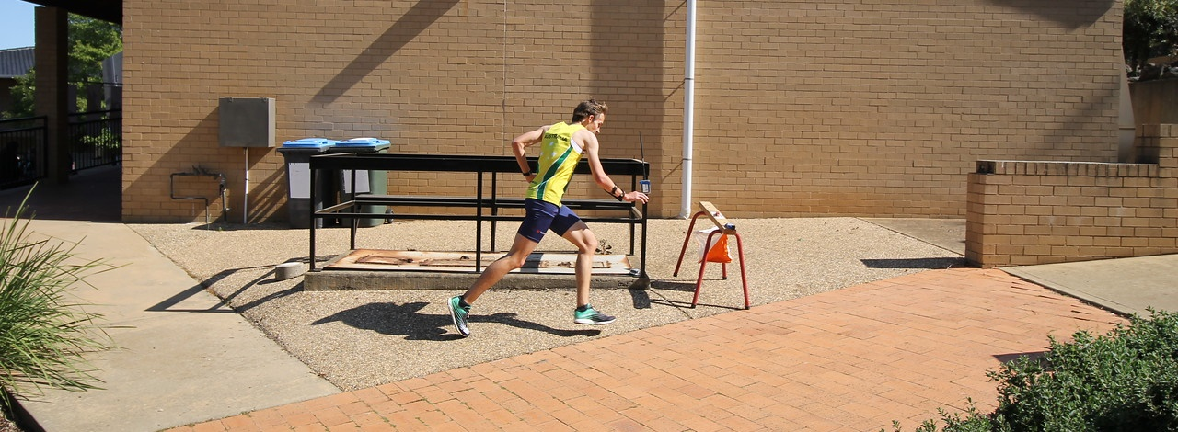

Programme

Date / Time | Activity
Friday 21 Feb Morning | Athletes Arrive
Friday 21 Feb 6:00 pm | Snap Series Sprint Event, Stirling
Saturday 22 Feb Morning | Sprint Trainings
Saturday 22 Feb Evening | Sprint Race
Sunday 23 Feb Morning | Knockout Qualifiers, Trinity College
Sunday 23 Feb Evening | Knockout Final, Trinity College
Monday 24 Feb | Athletes Depart

Terrain

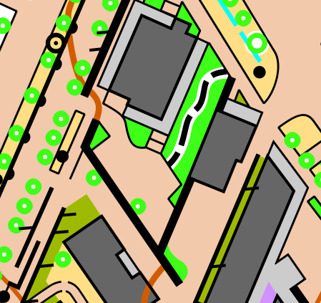
Stirling, Adelaide Hills | Further map previews to be released

Embargoed Areas

Certain areas have been embargoed for the Adelaide Sprint camp. Stirling (left) has been embargoed for the Friday 21st Snap Sprint Series event and Trinity College (right) for the Sunday 23rd knockout sprint event.
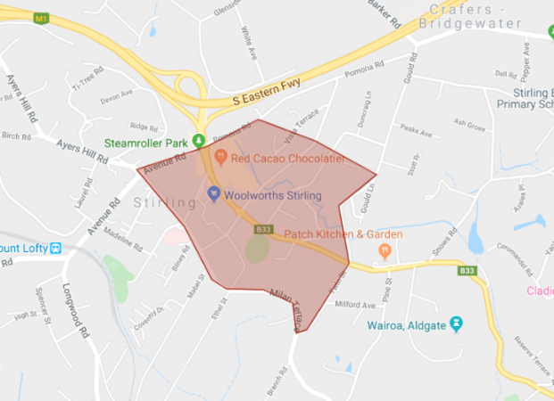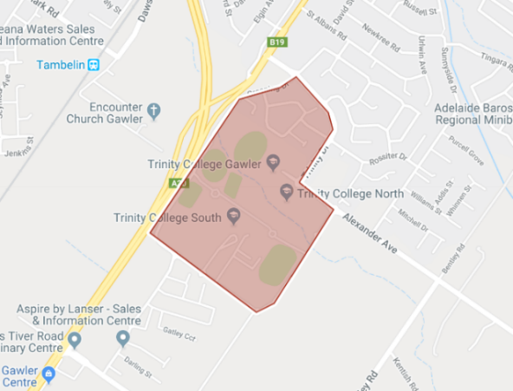
An interactive map of all embargoed areas in South Australia can be reached at:
http://tiny.cc/adelaideembargoes

Punching System

A combination of tapes, streamers and Sport Ident punching system will be used throughout the training camp.
Sport Ident Air+ may be featured during the camp (yet to be confirmed).

Clothing

There are no special regulations applying to runners concerning the type of clothing they choose to wear. But the organisers recommend use of shorts and light weight shirts / singlets in urban areas. Further clothing recommendations may follow if a bush area is selected.
It is forbidden to use shoes with spikes in the Sprint competition and in Sprint training areas.

Entries

All athletes attending must pre-enter though Eventor before the 14th of February 2020 at:
https://eventor.orienteering.asn.au/Events?startDate=2020-02-21&endDate=2020-03-31&organisations=7
* Please note that each day is listed as a separate event, including the Snap Sprint Series on Friday 21st. Please enter all events you will be attending *

Entry Fees

Sunday Only | $25
Saturday + Sunday | $45
Friday + Saturday + Sunday | $55
Snap Sprint Series | TBA

Please note these prices are provisional and subject to change

Climate and Weather

The climate in Adelaide during February can be summarized as warm and dry.
February is in the summer in Adelaide and is typically the warmest month of the year. Daytime maximum temperatures average around a comfortable 29°C, whilst at night 16°C is normal.
Source: Weather2Visit

Visas

Any international athletes interested in attending may require a travel visa. Please consult the link below to the Australian Department of Home Affairs for all the required information regarding entry visas.
https://immi.homeaffairs.gov.au/visas
If an official invitation letter from the Adelaide Sprint Camp is required please make an official request to the following email address: evalin.b@gmail.com

Event Organisers

Event Director: Evalin Brautigam
Mobile: 0434148488
Email: evalin.b@gmail.com

Friday 21st Snap Sprint Series
Course setter & Controller: Angus Haines
Mobile: 0478822476
Email: angushaineswork@gmail.com

Sponsors

