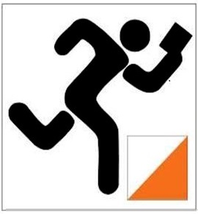
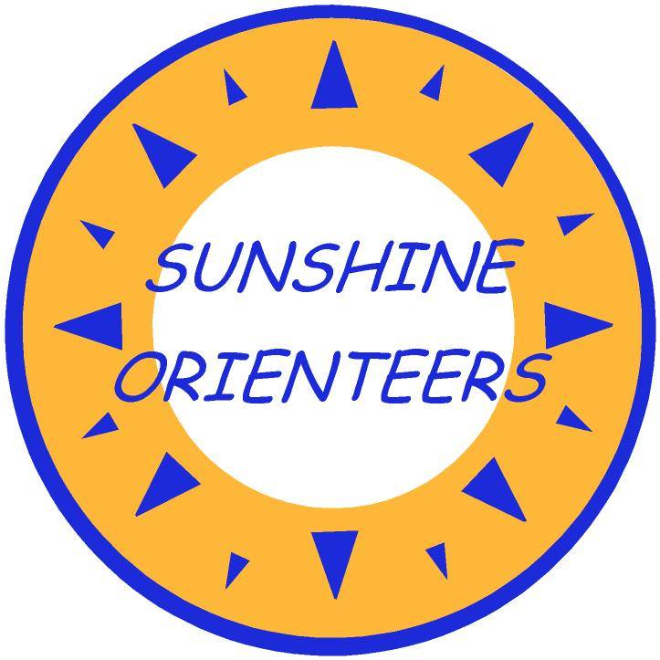
With the continued easing of COVID-19 restrictions from 1-June in Qld, allowing state wide travel for recreation, Sunshine Orienteers are continuing our socially-distanced DIY version of Night Navigation or Park Orienteering through June. The next three event locations are as follows

Sat 6 June to Wed 10-June: Buderim Parks
Sat 13June to Wed 17-June: Sunrise Beach
Sat 20-June to Wed 24-June: Sunshine Cove, Maroochydore
Course Maps will be PUBLISHED FOR YOU TO PRINT on the Eventor Website via Documents and Links
General Instructions:
- Choose and print the course map you need 40 min Score or 5 km Line from the Documents and Links section on the Eventor page
- Run anytime Sat morning to Wed evening
- Run alone OR with immediate family OR with one or two other people
- The "normal" start/finish location will be described in the Eventor General Information and shown on the Course maps.
- If you have installed MapRunF version 4.8.8 you can “Start Anywhere”
- Download the MapRun course you want from Queensland / Sunshine Coast / Night Nav - check the course name and date.
- Open the event, tap "Go to Start" and visit any control
- That control will become your Start and Finish
- The original Start/Finish will become another control number
- Remember to finish where you started.
TAKE CARE NOT TO RUN BACK THROUGH THE FINISH UNTIL YOU WISH TO COMPLETE YOUR RUN!
- You are allowed to DIY NIght Nav in the daytime!
- No cash or PIN is required
- Look out for the Results Email on Thurs

