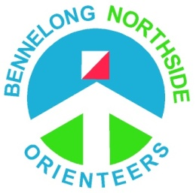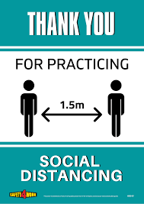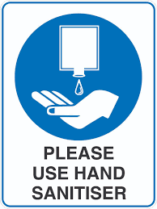
Bennelong Northside Orienteers
Covid Safety Information for Participants for Moonlight Madness July 29th 2020
This is a Covid conscious event. There are several conditions and restrictions that must be complied with for the event to proceed. These are listed below. Further details can be found on the ONSW website at https://onsw.asn.au/covid-19-updates
- Social distancing should be maintained at all times. Parents with young children should ensure their children exercise social distancing except with family members they live with.
- Please limit your time at the event. Don’t arrive unnecessarily early, and leave as soon as possible after your run. No results will be on display at the event – individual results will be available live on-line, and Eventor results will be published as soon as possible after the event.
- You must not attend the event if you meet any of the conditions identified by Health NSW as requiring self-isolation, or if you are unwell. This includes having have been in Victoria in the last 14 days, or if you visited certain areas in Sydney in the recent past. If in doubt, check.
- All attendees, whether competing or not, should register in Eventor – there is a “Does not participate” class for those not actually running, and a “NSW Casuals” club for those not already a member of a club. You can join the Casuals club and enter the “Does not participate” class free of charge. By registering in Eventor you will be required to provide contact details.
- Hand sanitising and/or hand washing should be done before and after the event. Hand sanitiser will be available but it is advisable to bring your own.
- Avoid touching of surfaces. Take care to only pick up the map you are using.
- Near controls be considerate of other people and respect the requirements of social distancing.
- When downloading after finishing, move away as quickly as possible. Avoid queuing – if necessary, come back later.

