MTBO National Series Round 3
WA MTBO Championships
Margaret River
Bulletin 2

The Orienteering Association of WA invites riders to attend the final round of the 2014 MTBO National Series, to be held in and around the picturesque tourist destination of Margaret River, WA. This region boasts some great tourist spots including wineries, restaurants, adventure activities and food, in addition to also being a quality mountain biking destination and hosting part of the Cape to Cape mountain bike race.
Margaret River is located approximately 3.5 hours’ drive south of Perth and is right near the coast for those also into beach activities, boasting world class surfing.
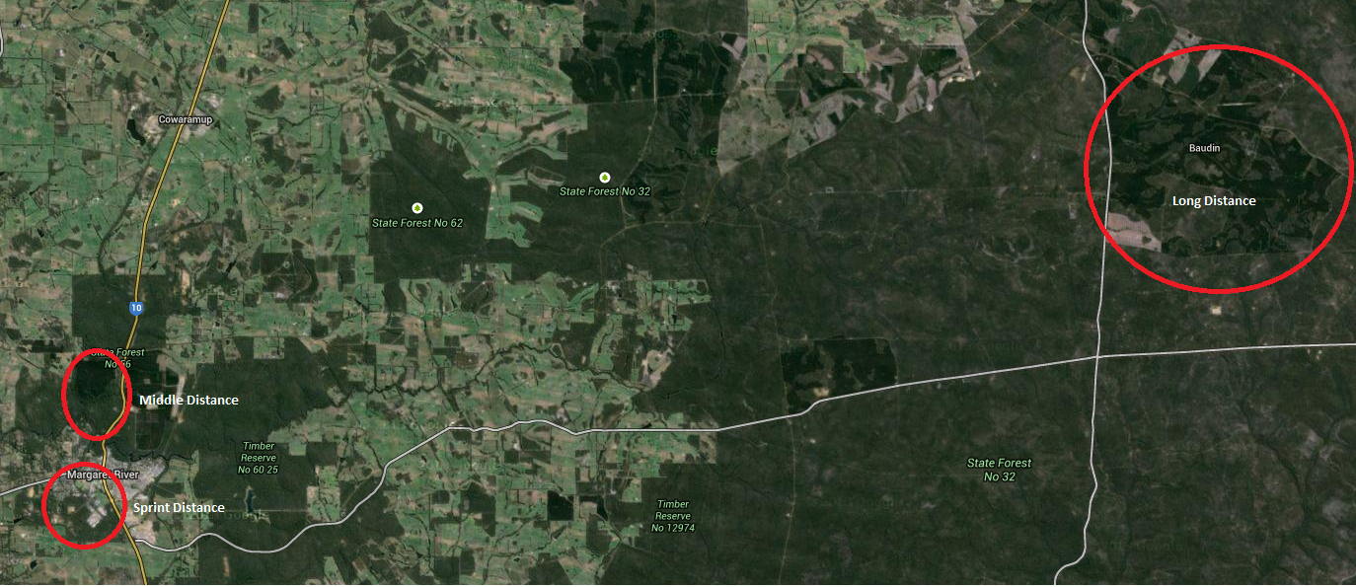

The event weekend will feature three races:
- Friday October 10th (afternoon) – WA Long Distance Championships
- Saturday October 11th (morning) – WA Middle Distance Championships
- Saturday October 11th (afternoon) – sprint distance event

This event also concludes the National Orienteering Carnival (Karrak Karnival) that works its way from Perth to Margaret River over the period September 27 to October 5 and Sprint the SW on October 7-8 (Bunbury and Margaret River region).

Course/class combination:
For the three events, the same course/class combinations will be offered across all races:

Course | Class
1 Senior | M21
2 Senior  Junior | W21, M40  M20
3 Senior  Junior | W40, M50  W20, M16
4 Senior  Junior | W50, M60  W16
5 Senior  Junior | W60, W70, W80, M70, M80  W14, M14

Expected Winning Times (in minutes): (as per revised OA operations manual 2014)

 | Long Distance | Middle Distance | Sprint Distance
Junior Men | 84-92 | 44-48 | 16-20
Junior Women | 68-76 | 36-40 | 16-20
Senior/Masters Men | 105-115 | 55-60 | 20-25
Senior/Masters Women | 85-95 | 45-50 | 20-25

WA Long Distance Championships

Location: Baudin Plantation, 55km by road east of Margaret River
Start times: from 1pm
Terrain: Mostly flat terrain at the headwaters or Margaret River, with some slightly steep gullies in parts. Mature pine plantation with blocks of remnant native vegetation. Tracks generally firm, but riding speed slowed by fallen leaves and sticks, thick cover of pine needles in the plantation, and undergrowth on tracks in native bush. Some parts are sandy, other wetter areas have deep ruts from forestry machinery. Trail bikes have used some trails and often these are easier to ride. Otherwise the tracks get very little if any traffic, so expect tracks and junctions to be less distinct because of a cover of leaf litter.
Map: Margaret’s Other End. 1:20 000, 5m contours. Approx. 30x30cm
Notes: Most of the native vegetation is dense, so for clarity all native forest has been mapped as dense (green). Most of the pine plantation is mature, and mapped as open forest (white). Some dense young pine is mapped as green with a lighter symbol than used for native forest. In the mature pine, some rows of trees have been felled to thin out the forest, and these can be mistaken for tracks. Tree stumps and/or a central mound will indicate a felled row rather than a track, these rows are not rideable unless mapped as a track or an optional marked route (purple dashed line) and marked in the terrain with tape. Marked routes have been created in a few locations to assist in course setting options. These will mostly be equivalent to slow riding.

Facilites Portable toilet. Mobile phone coverage is weak and patchy with Telstra. Nearest shops are Busselton and Margaret River – no water provided on courses.
Course close: 5pm
Setter: Duncan Sullivan
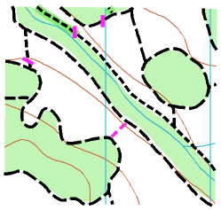

WA Middle Distance Championships

Location: Wharncliffe Mill, Margaret River
Start times: from 9am
Terrain: Pine & native forest with dedicated MTB trails
Map: Carters’ Pines. 1:10 000, 5m contours. A3
Notes: The area is a mix of pine and native forest, with much of the pine forest thinned by logging. These areas are open but presently marked as ‘rough open, scattered trees’ (unrideable land – see the symbol set below). At the time of writing, the Forest Products Commission had not yet decided on further logging in the area. If they do so, the western part of the map will have significant out of bounds areas that we may not enter. This will be advised closer to the event.

Many of the single tracks are single directional and will be marked as such on the map (see one way symbol in the symbol set below). This is done mainly to prevent incidents with other trail users on the day and because these tracks are meant to be ridden in the direction indicated. Please do not ride them the wrong way.
Facilities: Toilets, showers for campers, camp kitchen. Margaret River township is a short ride away.
Course close: 12:30pm
Setter: Ian Dalton
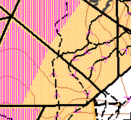

Sprint Distance Event

Location: Margaret River Leisure Centre, Margaret River
Start times: from 2pm
Terrain: Native bush tracks and urban parklands, minimal climb on all courses
Map: Gloucester Park. 1:7500, 5m contours. Approx. 30cm x 30cm
Notes: The course contains a mixture of fast-to-medium riding tracks, residential roads, parklands, high school and sporting grounds. Please be courteous to other area users. There are some out of bounds areas including, but not limited to, major roads.
Facilities: Toilet, water, shops nearby, skate park.
Course close: 4:30pm
Setter: Ricky Thackray
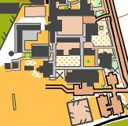

General course notes
WA uses an overgrown track symbol, a mid green overlay on a track symbol indicating appropriate riding speed. These tracks typically have 1.5-3m high shrubs growing from the original track surface that may hinder riding speed of ease of seeing where the track goes. A gap in the trees and the ground surface will distinguish the actual track from surrounding bush.

Fallen logs mapped as obstructions may be climbed over, but it is often easier and allowable to ride or walk around them in the forest. In places motor bikes or 4WD vehicles have created a path around these obstructions.

Notes on symbols to be used across events

The following symbols will be used to denote areas across all maps:

Track symbols
Rideable land

Unrideable land
Other symbols
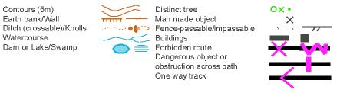
National MTBO League:
The Sprint, Middle and Long Distance MTBO Championships comprise the third and final round of the 2014 National MTBO League Elite, Junior and Masters Division Series. For information on classes eligible for the Australian National MTBO League, Juniors and Masters Division, see the website http://www.orienteering.asn.au/mountainbike/MTBONOL/

EVENT ENTRY
Online entry is now open for all events, with secure payment via PayPal through Eventor, Orienteering Australia’s online entry system. Normal entry prices apply up to and including Sunday 21st September. Late entries are possible after that to Sunday 28th September, but attract a late fee of $10 per event. Entries on the day will be offered but entrants will not be included in Championship categories.

Visit http://eventor.orienteering.asn.au/Events to enter
Entry Tips for using Eventor: After you’ve created your Eventor user ID, add your club (n/a if not a club member). From the Eventor Event Calendar, tick all applicable events when you enter, as this will produce a single invoice for payment instead of 3 separate ones, allowing you to pay in a single transaction. If you have difficulty using Eventor contact the organiser for assistance or read the help document located within the event entry information screen.

Entry Fees (Orienteering club members discount $10 adult/$5 junior):
2014 WA MTBO Middle Distance Championships: Senior: $35 Junior: $20
2014 WA MTBO Long Distance Championships: Senior: $35 Junior: $20
2014 MTBO Sprint event: Senior: $30 Junior: $15

SportIdent Hire: All competitors will require their own SportIdent stick. They are available for hire under the Additional Services menu on Eventor for an additional fee per event. Alternatively if you wish to buy your own contact the organiser to enquire on purchase.

Member Discount: Members of an IOF recognised orienteering association or club may claim a discount per event (ie $30 adult/$15 junior for 3 events). Non member competitors should select the ‘Adult/Junior casual non-member fee’ option under the Additional Services menu on Eventor.

Map boards: A basic map board which can be attached to your handlebars can be hired at the event(s).

Refund Policy: Refunds are possible prior to the event by contacting the organiser by phone or email. Refunds requested prior to the last date of acceptance of entries will be made minus $15 service charge. After this date no refunds are possible.

TRAVEL AND ACCOMMODATION
The best way to get to the event is to fly to Perth (if you do not already live there) and drive to Margaret River. At this stage it is anticipated that the long distance event will require motorised transport to get to and from the town (STC). The sprint and middle distance will be located a short ride from the town centre.

There are many accommodation options in and near town including holiday villas, caravan parks and B&Bs. The event is to be held during the WA school holidays so it is best to book sooner rather than later. The event organisers’ preferred accommodation option is the Wharncliffe Mill Bush Retreat http://www.wharncliffemill.com.au/ , which is also the Event Centre and assembly area for the middle distance event. The more people who stay here, the better will be our ability to use their facilities, which includes cabins, camping and dorm options. It is also located within the heart of the best mountain biking trails in SW WA. Please mention that you are staying as part of the mountain bike orienteering carnival so that we can receive preferential treatment.

The Margaret River Tourist Park http://www.margaretrivertouristpark.com.au/ is also located close to the town centre and to the assembly area for the sprint distance event. For other accommodation options in and near Margaret River, check out http://www.margaretriver.com/accommodation/

RESULTS AND PRIZE GIVING

The dinner venue is Goodfellas, 97 Bussell Hwy, Margaret River. Dinner will be from 6:30pm Saturday, October 11, with prize giving throughout the evening. For a sample menu, go to http://img.dimmi.com.au/menu/19499-goodfellas-margaret-river-menu-dinner.pdf

There is an option in Eventor to elect to attend the dinner to get an idea of numbers. Please choose this option if you wish to attend. There is no need for upfront payment if choosing this option.

CONTACTS/MAPPERS

Event organiser/primary contact

Ricky Thackray (WA MTBO Convenor, sprint)
rickythackray@hotmail.com
0459 486 739

Co-organisers

Ian Dalton (middle)
ian_dalton@hotmail.com

Duncan Sullivan (long)
duncange@bigpond.net.au
08 9285 0290

Course vetter

Phil Dufty
phil.dufty@westnet.com.au

