GARINGAL ORIENTEERS 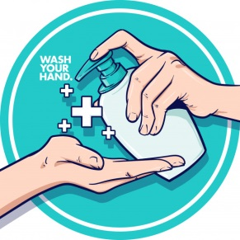
WESTERN SYDNEY SUMMER SERIES #2 BEAUMONT HILLS DECEMBER 13 2020
COVID SAFETY INFORMATION

This is a COVID-conscious event. There are several conditions and restrictions that must be complied with in order for the event to proceed. These are summarised below. Further details can be found on the ONSW website at https://www.onsw.asn.au/covid-19-updates
DO NOT ATTEND if you are unwell, have recently been in Victoria or if you must self-isolate under NSW Health COVID guidance (see above website or https://www.nsw.gov.au/covid-19/latest-news-and-updates)

- This is a “get in, orienteer and get out” event. No gatherings are permitted before or after the event. No results will be on display, but they will be online.

- Social distancing should be maintained at all times. Parents with young children should ensure their children exercise social distancing except with those family members they live with.

- Contact details are required for all attendees at an event; spectators and competitors. This can be done:

  - Before the event through Eventor (non-club members will need to create a ‘Casual member’ registration)
  - On the day using the simpler EOD webform (QR code at the Registration desk).

We already have details for Season Pass holders.

- Hand sanitising and/or hand washing should be undertaken before and after competing. Hand sanitiser will be available but it is also advisable to bring your own.

- Maps will be available on Eventor from 7pm of the evening prior to the event. This is for course planning. Printed maps will be available at the event and can be collected at the meeting point.

- Control clue sheets will be printed on the maps. Loose sheets will not be provided.

- Avoid unnecessary touching of surfaces. Take care to only touch and pick up the map that you are using. Avoid touching the SI units other than to insert the SI stick if not using SIAC. There will not be a box for keys.

- Near controls, please be considerate of other people and respect their requirements for social distancing.

- At the Finish and download be conscious of SI staff and move away as quickly as possible.

