GARINGAL ORIENTEERS 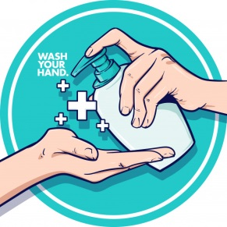
SYDNEY SUMMER SERIES #16 COLLAROY JANUARY 20 2021
COVID SAFETY INFORMATION

This is a COVID-conscious event. There are several conditions and restrictions that must be complied with in order for the event to proceed. These are summarised below. Further details can be found on the ONSW website at https://www.onsw.asn.au/covid-19-updates and in the Garingal COVID safety plan.
DO NOT ATTEND if you are unwell or if you must self-isolate under NSW Health COVID guidance (see above website or https://www.nsw.gov.au/covid-19/latest-news-and-updates).
You should also not attend if you live in regions where the NSW or Australian Government has restricted travel. Organisers will also monitor whether participants have been to a current COVID-19 case locations in NSW and will refuse entry if that is appropriate.

- Social distancing of 1.5m should be maintained at all times. Parents with young children should ensure their children exercise social distancing except with those family members they live with.

- There should be no gatherings before or after the event.

- Contact details are required for all attendees at an event; spectators and competitors. This can be done:

  - Before the event through Eventor (non-club members will need to create a ‘Casual member’ registration)
  - On the day using the simpler EOD webform (QR code at the Registration desk).

We already have details for Season Pass holders.

- Hand sanitising and/or hand washing should be undertaken before and after competing. Hand sanitiser will be available but it is also advisable to bring your own.

- Maps will be available on Eventor from 7pm of the evening prior to the event. This is for course planning. Printed maps will be available at the event and can be collected at the meeting point.

- Control clue sheets will also be available on Eventor. They will also be printed on the maps. Loose sheets will not be provided.

- Avoid unnecessary touching of surfaces. Take care to only touch and pick up the map that you are using. Avoid touching the SI units other than to insert the SI stick if not using SIAC. There will not be a box for keys.

- Near controls, please be considerate of other people and respect their requirements for social distancing.

- At the Finish and download be conscious of SI staff and move away as quickly as possible.

